NAMA : ____________________________________________________________________

TINGKATAN : ____________________________________________________________________

SULIT
1119/2
BAHASA INGGERIS
Kertas 2
2 jam 15 minit
_____________________________________________________
TINGKATAN 4

BAHASA INGGERIS
Kertas 2
Dua jam lima belas minit

JANGAN BUKA KERTAS SOALAN INI SEHINGGA DIBERITAHU
For Examiner’s Use
Section | Total | Marks
A | 15
B | 10
C | 25
D | 20
Total | 70

Arahan

1. Tulis nama dan tingkatan anda pada ruang yang disediakan.
2. Kertas soalan ini mengandungi 4 bahagian: Bahagian A, Bahagian B, Bahagian C dan Bahagian D.
3. Jawab semua bahagian dalam kertas soalan ini.
4. Soalan-soalan dalam Bahagian A mempunyai empat pilihan jawapan.

Kertas soalan ini mengandungi 16 halaman bercetak

[LIHAT SEBELAH
SULIT
Section A
[15 Marks]
[Time suggested: 25 minutes]

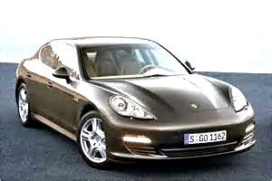

2014 Porsche Panamera

It may look the same, but the five-door Porsche gets stronger and longer.

The naturally aspirated, entry-level 3.6-liter V-6 gets 10 more horsepower, for a total of 310.

The engine is Porsche's own—essentially the 4.8-liter V-8 minus a cylinder from each bank.
1 From the advertisement above, we know that
A the 2014 Porsche Panamera has 10 horsepower
B the engine of the 2014 Porsche Panamera is the 4.8-litre V-8
C the 2014 Porsche Panamera is stronger and longer
D the 2014 Porsche Panamera looks the same as its older model

Fuzzy Bananas
Peel the bananas and cut them in half.
Wrap them in cling film and place in the freezing compartment of the refrogerator.
When the bananas are already frozen, dip them in a mixture of peanut butter and honey.
Roll the bananas in grated coconut and serve immediately.

Step 1 Peel and slice the bananas
Step 2 Freeze the bananas
Step 3 ?
Step 4 Coat with grated coconut
2 The chart above represents the steps in making Fuzzy Bananas. Step 3 in the chart is

A wrap in cling film
B place in refrigerator
C dip in honey mixture
D coat with peanut butter

We apologise but the use of mobile phones is not permitted
in this establishment.
Customers are welcome to use the phone at the service counter.
3 Which of the following sentences best explains the sign above?
A This establishment does not have a phone at the service counter
B Customers can request to use the establishment’s mobile phones
C Customers have to use their own mobile phones in this establishment
D Customers have to switch off their mobile phones inside this establishment

Ipoh, Sunday – The F1 Car Carnival held at the Mall Complex here attracted a large crowd. The visitors managed to catch a glimpse of the latest racing cars. Many were seen buying F1 merchandise like shirts, key chains and other stuff. Many of them had come from all parts of the country to watch the race and attend the carnival.
4 According to the news report above, the following activities took place at the carnival except
A selling of F1 goods
B display of cars
C concert
D car race

No parking charges after 8 p.m
5 The sign says that
A all parking charges must be paid before 8 p.m
B there is a parking charge before 8 p.m
C parking is not allowed after 8 p.m
D parking is free from 8 a.m to 8 p.m

Questions 6 and 7 are based on the label below.
Almond Instant Porridge
Directions:
1 Pour the contents in a bowl.
2 Fill the bowl with boiling water.
3 Cover the bowl and leave for two minutes.
4 Stir well and serve hot.

6 The bowl should be covered after
A adding the rice
B adding boiling water
C pouring the contents
D adding the dried prawns

7 The following are the ingredients used except
A salt
B meat
C dried carrot
D soyabean oil

Turkish rescue workers saved a 45-year-old mother of five from the rubble of her home here yesterday, 105 hours after it collapsed in the massive South Asian earthquake. Rashida Farooq was pulled to safety amid cheers from a crowd of about 100 locals who had watched the drama unfold over five hours.
Nearby, a five-year-old girl crawled free from a crumpled building as desperate rescue workers, who did not know she was there, dug for survivors. Relatives said Lard Hussein crawled out from the rubble by herself, wearing the red dress she had on when the 7.6 magnitude quake struck on Saturday.
8 The word rubble can be replaced with

A site
B ruins
C rubbish
D grounds

Questions 9-15 are based on the following passage. Choose the best answer to fill in each blank.

Local and foreign tourists in Kuala Lumpur will be in for a great cultural treat. For the first time, performers from five Asian countries will be________ ( ) in for the launch of Citrawarna Malaysia, an event that showcases the country’s rich culture, arts and traditions.

It will be an exciting event with a rich ________ ( ) of dances, performances and music from these countries. it will indeed be a photographer’s dream to ________ ( ) photos of the dancers and performers in their magnificent costumes.

The Citrawarna Malaysia atmosphere will be enriching ________ ( ) intoxicating. The crowd will be surrounded by lights, colours, beautiful and friendly performers moving to exotic music from ________ ( ) countries. it will definitely be an event to look forward to.

Cultural troupes from China, South Korea, Indonesia, the Philippines and Thailand are expected to spice up ________ ( ) show at Stadium Merdeka next Saturday.

There will be a rehearsal before the actual event. All the performers are expected to attend the rehearsal. Citrawarna Malaysia will be ideal for fostering ties ________ ( ) Asian countries. it will also make Malaysians aware of their rich cultural heritage as well as learn more about the cultural dances and traditional costumes of people from neighbouring countries.

9 A fly

B flies

C flew

D flown

10 A range

B array

C type

D kind

11 A take

B takes

C took

D taking

12 A as

B for

C and

D since

13 A my

B his

C your

D their

14 A a

B an

C the

D -

15 A after

B about

C along

D among

Section B
[10 Marks
[Time suggested]

Read the advertisement below carefully. Then, complete the diagram that follows.
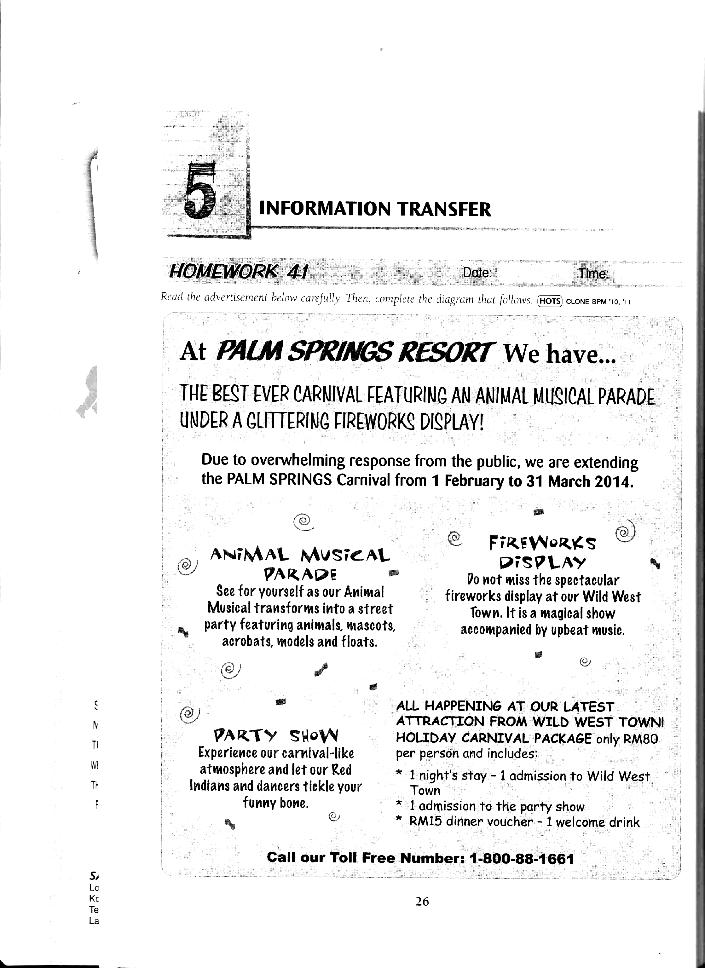

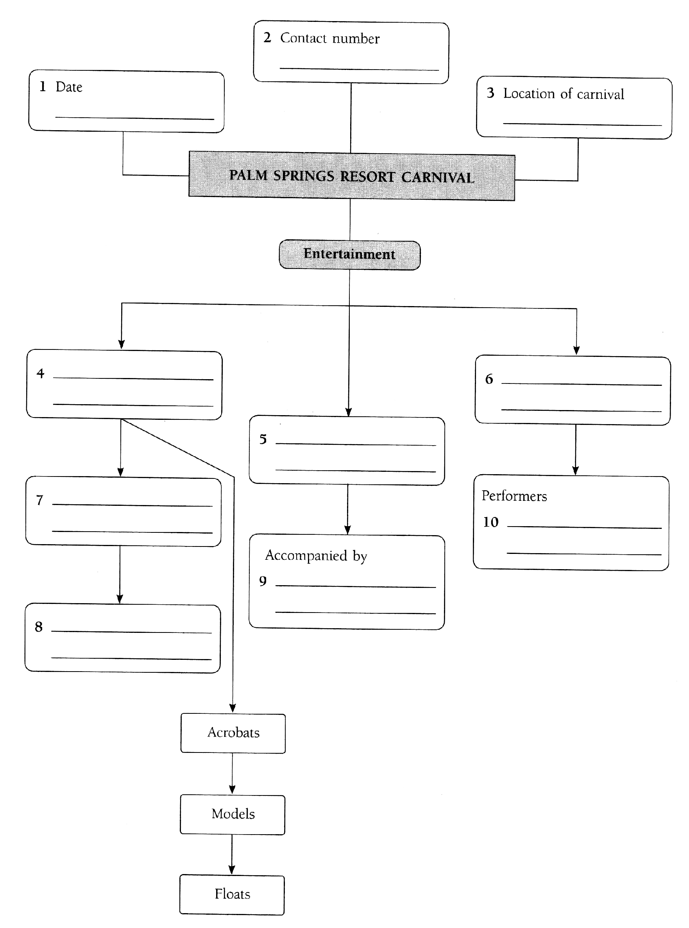

Section C
[25 Marks]
[Time suggested: 50 minutes]
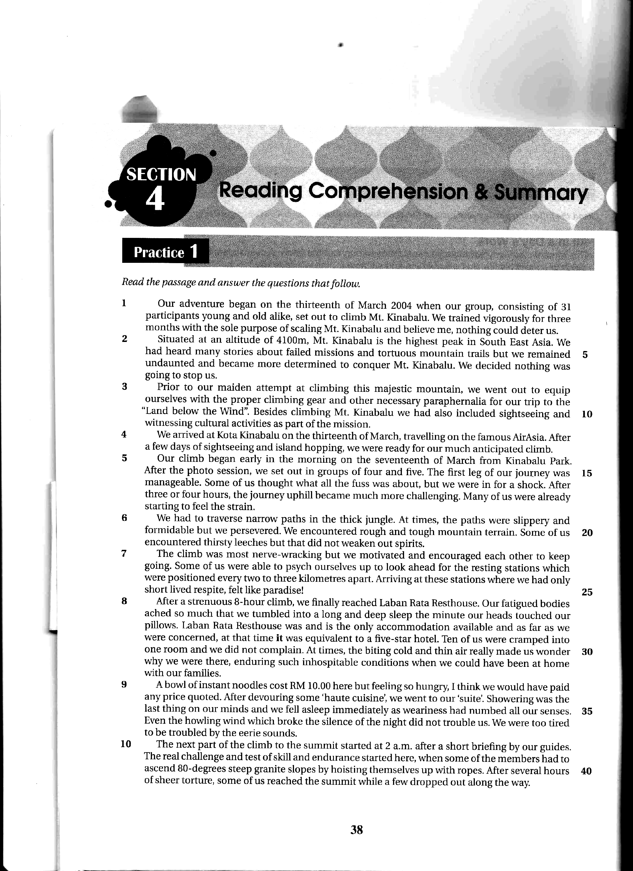

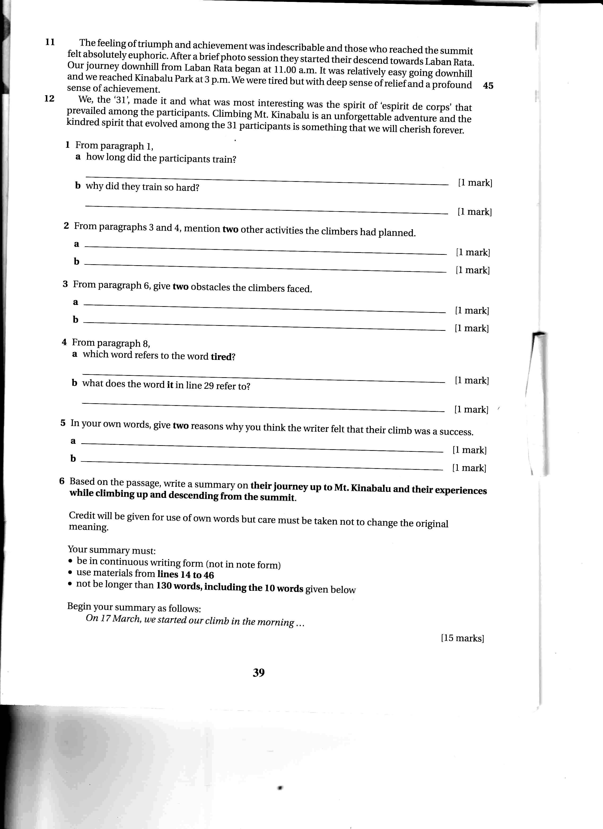

26 From paragraph 1,

a) how long did the participants train?

________________________________________________________________________ [1 mark]

b) why did they train so hard?

________________________________________________________________________ [1 mark]

27 From paragraphs 3 and 4, mention two other activities the climbers had planned.

Activity 1: _________________________________________________________________ [1 mark]

Activity 2: __________________________________________________________________ [1 mark]

28 From paragraph 6, give two obstacles the climbers faced.

Obstacle 1: _________________________________________________________________ [1 mark]

Obstacle 2: _________________________________________________________________ [1 mark]

29 From paragraph 8,

a) which word refers to the word tired?

________________________________________________________________________ [1 mark]

b) what does the word it in line 29 refer to?

________________________________________________________________________ [1 mark]

30 In your own words, give two reasons why you think the writer felt that their climb was a success.

i) ______________________________________________________________________ [1 mark]

ii) ______________________________________________________________________ [1 mark]

31 Based on the passage, write a summary on
- their journey up to Mt. Kinabalu and
- their experiences while climbing up and descending from the summit

Credit will be given for use of own words but care must be taken not to change the original meaning.

Your summary must:
- Be in continuous writing form (not in note form)
- Use materials from lines 14 to 46
- Not be longer than 130 words, including the 10 words given below

Begin your summary as follows:

On 17 March, we started our climb in the morning…
____________________________________________________________________________________________________________________________________________________________________________________________________________________________________
________________________________________________________________________________________________________________________________________________________________________________________________________________________________________________________________________________________________________________________________________________________________________________________________________________________________________________________________________________________________________________________________________________________________________________________________________________________________________________________________________________________________________________________________________________________________________________________________________________________________________________________________________________________________________________________________________________________________________________________________________________________________________________________________________________________________________________________________________________________________________________________________________________________________________________________________________________________________________________________________________________________________________________________________________________________________________________________________________________________________________________________________________________________________________________________________________________________________________________________________________________________________________________________________________________________________________________________________________________________________________________________________________________________________
____________________________________________________________________________________________________________________________________________________________________________________________________________________________________
________________________________________________________________________________________________________________________________________________________
____________________________________________________________________________________________________________________________________________________________________________________________________________________________________
________________________________________________________________________________________________________________________________________________________
____________________________________________________________________________________________________________________________________________________________________________________________________________________________________

Section D
[20 Marks]

32 Read the poem He Had Such Quiet Eyes below and answer the questions that follow.

He Had Such Quiet Eyes

He had such quiet eyes
She did not realise
They were two pools of lies
Layered with thinnest ice
To her, those quiet eyes
Were breathing desolate sighs
Imploring her to be nice
And to render him paradise

If only she’d been wise
And had listened to the advice
Never to compromise
With pleasure-seeking guys
She’d be free from “the hows and whys”

Now here’s a bit of advice
Be sure that nice really means nice
Then you’ll never be losing at dice
Though you may lose your heart once or twice
Bibsy Soenharjo
a) Why do you think the woman fell for the man’s quiet eyes?

________________________________________________________________________ [1 mark]
b) (i) In stanza 1, the phrase ‘two pools of lies’ refers to

________________________________________________________________________ [1 mark]
(ii) In stanza 2, indicate the phrase which shows deceitful and selfish man.

________________________________________________________________________ [1 mark]
c) What quality would you like best in a future life partner? Give a reason for your answer.

Quality: _________________________________________________________________ [1 mark]

Reason: _________________________________________________________________ [1 mark]

33 The following is the short story studied in the literature component in English language.
The Fruitcake Special by Frank Brennan
Read the extracts (a) and (b) from the short story The Fruitcake Special below and answer the questions that follow.
a)
Aunt Mimi looked at me and smiled. “Anna, my little girl…but look at you: you’re not a little girl any more, you’re a twenty-three-year-old woman already! How time flies!”
“Actually, I’m twenty-seven, Aunt Mimi,” I said. She always got my age wrong.
“So soon? And you’re not married yet? Your mother was married when she was eighteen. Eighteen! And you were born when she was nineteen!” Aunt Mimi looked sad as she said this.
She decided to say what she thought at once – as she always did.
“So when are you going to bring a nice boy home?” she asked, looking at me right in the eye.
“There was that boy Armstrong you saw two years ago. He was nice,” said Momma, trying to help me.
“Momma, Armstrong was the pizza delivery man,” I tried to explain, but Momma never did listen.
“Armstrong was here a few times. I liked him,” said Momma.
a) How old did Aunt Mimi think Anna was? ________________________________________________________________________ [1 mark]
b) What is Aunt Mimi hoping for Anna? ________________________________________________________________________ [1 mark]
c) Who is Armstrong? ________________________________________________________________________ [1 mark]
d) If you were Anna, how would you feel about your mother and aunt asking you to find a boy?
Give a reason for your answer.
Feeling: _________________________________________________________________ [1 mark]
Reason: _________________________________________________________________ [1 mark]

Extract (b)
Sabina continued: “So David wants you to accept a bit of money to make up for any disappointments you may have had, then you can go back to making perfumes at the factory again. Right, David?”
“Absolutely, darling,” said Mr Amos before turning to me again. “Well, Anna, I hope this has helped to…er…clear things up a little. I’m sorry there had to be this, er, confusion. I hope this has sorted things out between us.”
I stood watching Sabina smile as she put her fingers down his collar.
“Well, Mr David Amos,” I said, “perhaps you can use your famous expert nose to sort this out, too!” I had reached into my handbag for something to throw when I saw Sabina laughing. I took the top off the first thing I found and threw everything that was in the bottle all over the front of Sabina’s dress.
a) Do you think Anna accepted the money that Mr Amos offered?
________________________________________________________________________ [1 mark]
b) What reason did Sabina have for speaking on behalf of Mr Amos?
________________________________________________________________________ [1 mark]
c) Why did Anna throw the contents of the bottle on Sabina?
________________________________________________________________________ [1 mark]
d) From the above passage, what is your opinion of Mr Amos? Give a reason for your answer.
Opinion: ________________________________________________________________ [1 mark]
Reason: _________________________________________________________________ [1 mark]

c) Using the details from the short story The Fruitcake Special you have studied, write about one of the themes in the story. Write your answer with close reference to the text. State one reason for your choice and elaborate on it.
[5 marks]
____________________________________________________________________________________________________________________________________________________________________________________________________________________________________________________________________________________________________________________________________________________________________________________________________________________________________________________________________________________________________________________________________________________________________________________________________________________________________________________________________________________________________________________________________________________________________________________________________________________________________________________________________________________________________________________________________________________________________________________________________________________________________________________________________________________________________________________________________________________________________________________________________________________________________________________________________________________________________________________________________________________________________________________________________________________________________________________________________________________________________________________________________________________________________________________________________________________________________________________________________________________________________________________________________________________________________________________________________________________________________________________________________________________________________________________________________________________________________________________________________________________________________________________________________________________________________________________________________________________________________________________________________________________________________________________________________________________________________________________________________________________________________________________________________________________________________________________________________________________________________________________________________________________________________________________________________________________________________________________________________________________________________________________________________________________________________________________________________________________________________________________________________________________________________________________________________________________________________________________________________________________________________________________________________________________________________________________________________________________________________________________________________________________________________________________________________________________________________________________________________________________________________________________________________________________________________________________________________________________________________________________________________________________________________________________________________________________________________________________________________________________________________________________________________________________________________________________________________________________________________________________________________________________________________________________________________________________________________________________________________________________________________________________________________________________________________________________________________________________________________________________________
________________________________________________________________________________________________________________________________________________________________________________________________________________________________________________________________________________________________________________
END OF QUESTION PAPER

