PRAKATA
Alhamdulilllah, Terima kasih kepada rakan-rakan guru dan team sumberpendidikan kerana menyediakan RPT 2021 untuk kegunaan guru-guru di Malaysia.
Muaturun Percuma…
**DILARANG UNTUK MENGAMBIL SEBARANG BENTUK DAN JENIS KEUNTUNGAN DARIPADA PIHAK KAMI DAN WEB INI SAMA ADA SECARA LANGSUNG ATAU TIDAK LANGSUNG.**
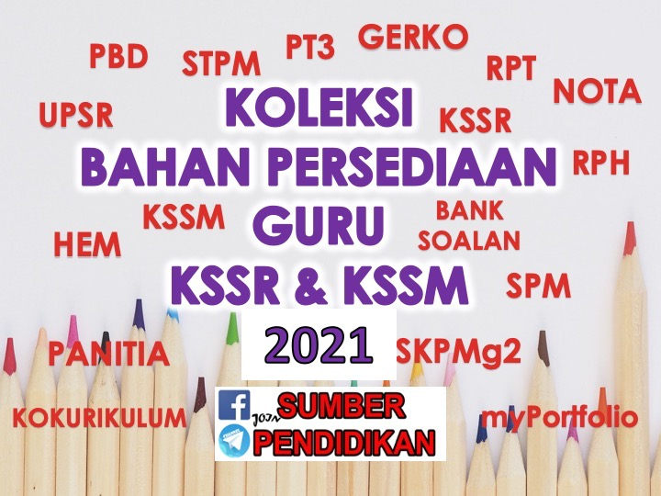

SCHEME OF WORK ENGLISH LANGUAGE FORM 3
YEAR 2021

WEEK | TYPES | LESSON | PAGE  (SOW) | THEME | UNIT  (CLOSE UP)
WEEK1
1 Januari – 3 Januari 2021

WEEK2
4 Januari – 10 Januari 2021

WEEK3
11 Januari – 17 Januari 2021

WEEK4  18 Januari – 24 Januari 2021 | TB | 1, 2, 3 | 27 - 29 | People and Culture | Family Ties
WEEK5  25 Januari – 31 Januari | TB | 4, 5, 6 | 30 - 32 | People and Culture | Family Ties
WEEK6  1 Februari – 7 Februari 2021 | TB | 7, 8, 9 | 33 - 35 | People and Culture | Family Ties
WEEK7  8 Februari – 14 Februari 2021 | NTB | 10 | 36 | N/A | Teacher to select
 | TB | 11, 12 | 37 – 38 | People and Culture | Food,Food, Food!
WEEK8  15 Februari – 21 Februari 2021 | TB | 13, 14, 15 | 39 - 41 | People and Culture | Food,Food, Food!
WEEK9  22 Februari – 28 Februari 2021 | TB | 16, 17 | 42 - 43 | People and Culture | Food,Food, Food!
WEEK10  1 Mac – 7 Mac 2021  WEEK11  8 Mac – 14 Mac 2021 | TB | 18, 19, 20 | 44 – 45 | People and Culture | Food,Food, Food!
 | NTB | 20 | 46 | N/A | Teacher to select
WEEK12  15 Mac – 21 Mac 2021 | TB | 21, 22, 23 | 47 – 49 | Health and Environment | The Wonders of Nature
WEEK13  22 Mac – 28 Mac 2021 | TB | 24, 25, 26 | 50 - 52 | Health and Environment | The Wonders of Nature
WEEK14
29 Mac – 4 April 2021

WEEK15  5 April – 11 April 2021 | TB | 27, 28, 29 | 53 - 55 | Health and Environment | The Wonders of Nature
WEEK16  12 April – 18 April 2021  WEEK17  19 April – 25 April 2021 | NTB | 30 | 56 | N/A | Teacher to select
 | TB | 31, 32 | 57 - 58 | Health and Environment | Special Relationships
WEEK18  26 April – 2 Mei 2021 | TB | 33, 34, 35 | 59 - 61 | Health and Environment | Special Relationships
WEEK19  3 Mei – 9 Mei 2021 | TB | 36, 37, 38 | 62 - 65 | Health and Environment | Special Relationships
WEEK20  10 Mei – 16 Mei 2021 | TB | 39 | 65 | Health and Environment | Special Relationships
 | NTB | 40 | 66 | N/A | Teacher to select
WEEK21  17 Mei – 23 Mei 2021 | TB | 41, 42, 43 | 67 - 69 | Science and Technology | A Place to Call Home
 | TB | 44, 45, 46 | 70 - 72 | Science and Technology | A Place to Call Home
WEEK22
24 Mei – 30 Mei 2021

WEEK23  31 Mei – 6 Jun 2021 | CUTI PERTENGAHAN TAHUN
WEEK24  7 Jun – 13 Jun 2021 | CUTI PERTENGAHAN TAHUN
WEEK25  14 Jun – 20 Jun 2021 | TB | 47, 48, 49 | 73 - 75 | Science and Technology | A Place to Call Home
WEEK26  21 Jun – 27 Jun 2021 | NTB | 50 | 76 | N/A | Teacher to select
 | TB | 51, 52 | 76 - 78 | Health and Environment | Ready, Steady, Go!
WEEK27  28 Jun – 4 Julai 2021 | TB | 53, 54, 55 | 79 – 81 | Health and Environment | Ready, Steady, Go!
WEEK28  5 Julai – 11 Julai 2021 | TB | 56, 57  (REVISION) | 82 | N/A | Teacher to select
 | TB | 58 | 83 | Health and Environment | Ready, Steady, Go!
WEEK29  12 Julai – 18 Julai 2021 | TB | 59, 60 | 84 – 85 | Health and Environment | Ready, Steady, Go!
 | NTB | 61 | 86 | N/A | Teacher to select
WEEK30  19 Julai – 25 Julai 2021 | CUTI PERTENGAHAN PENGGAL 2
WEEK31  26 Julai – 1 Ogos 2021 | TB | 62, 63, 64 | 87 – 89 | Health and Environment | Extreme Situations
WEEK32  2 Ogos – 8 Ogos 2021 | TB | 65, 66, 67 | 90 – 92 | Health and Environment | Extreme Situations
WEEK33  9 Ogos – 15 Ogos 2021 | TB | 68, 69, 70 | 93 - 95 | Health and Environment | Extreme Situations
WEEK34  16 Ogos – 22 Ogos 2021 | NTB | 71 | 96 | N/A | Teacher to select
 | TB | 72, 73 | 97 – 98 | People and Culture | Time to Spare
WEEK35  23 Ogos – 29 Ogos 2021 | TB | 74, 75 | 99–100 | People and Culture | Time to Spare
WEEK36  30 Ogos – 5 September 2021 | TB | 76, 77, 78 | 101-103 | People and Culture | Time to Spare
WEEK37  6 September – 12 September 2021 | TB | 79, 80 | 104-105 | People and Culture | Time to Spare
 | NTB | 81 | 106 | N/A | Teacher to select
WEEK38  13 September – 19 September 2021 | CUTI PERTENGAHAN PENGGAL 2
WEEK39  20 September – 26 September 2021 | TB | 82, 83, 84 | 107-109 | Science and Technology | High-Tech World
WEEK40  27 September – 3 Oktober 2021 | TB | 85, 86, 87 | 110-112 | Science and Technology | High-Tech World
WEEK41  4 Oktober – 10 Oktober 2021 | TB | 88, 89, 90 | 113-115 | Science and Technology | High-Tech World
WEEK42  11 Oktober – 17 Oktober 2021 | NTB | 91 | 116 | N/A | Teacher to select
 | TB | 92, 93 | 117-118 | People and Culture | That’s Entertainment
WEEK43  18 Oktober– 24 Oktober 2021 | TB | 94, 95, 96 | 119-121 | People and Culture | That’s Entertainment
WEEK44  25 Oktober– 31 Oktober 2021 | TB | 97, 98, 99 | 122-124 | People and Culture | That’s Entertainment
WEEK45  1 November – 7 November 2021 | TB | 100 | 125 | People and Culture | That’s Entertainment
 | NTB | 101 | 126 | N/A | Teacher to select
WEEK46  8 November – 14 November 2021 | TB | 102, 103, 104 | 127-129 | People and Culture | Lessons to Learn
37 | TB | 105 | 130 | People and Culture | Lessons to Learn
 | TB/NTB | 106  (REVISION) | 131 | N/A | Teacher to select
 | TB | 107 | 132 | People and Culture | Lessons to Learn
WEEK47  15 November – 21 November 2021 | NTB | 108 | 133 | N/A | Teacher to select
 | TB | 109, 110  (REVISION) | 134 - 135 | N/A | Teacher to select
WEEK48  22 November – 28 November 2021 | NTB | 111 – 112  (PBL) | 136 | N/A | Teacher to select

*NTB = NON TEXTBOOK BASED LESSON, TB = TEXTBOOK BASED LESSON

