PRAKATA
Alhamdulilllah, Terima kasih kepada rakan-rakan guru dan team sumberpendidikan kerana menyediakan RPT 2021 untuk kegunaan guru-guru di Malaysia.
Muaturun Percuma…
**DILARANG UNTUK MENGAMBIL SEBARANG BENTUK DAN JENIS KEUNTUNGAN DARIPADA PIHAK KAMI DAN WEB INI SAMA ADA SECARA LANGSUNG ATAU TIDAK LANGSUNG.**
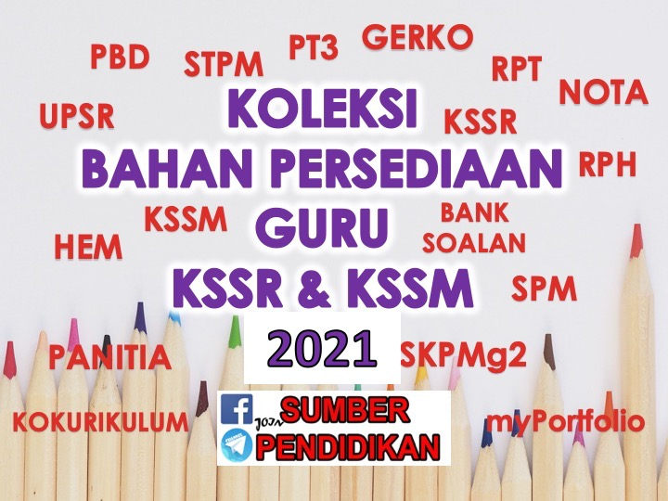

RPT MATHEMATICS YEAR 6 KSSR 2021
WEEK | CONTENT STANDARD | LEARNING STANDARD | NOTE
WEEK 1
1 Januari – 3 Januari 2021

WEEK 2
4 Januari – 10 Januari 2021

WEEK 3
11 Januari – 17 Januari 2021

WEEK 4  18 Januari – 24 Januari 2021 | 1.1 Application of any numbers. | i) Use a calculator to represent calculation including round off numbers and number patterns.
WEEK 5  25 Januari – 31 Januari | 1.2 Prime numbers | (i) Identify prime numbers within 100.
WEEK 6  1 Februari – 7 Februari 2021 | 1..3 Numbers up to seven digits | (i) Read, say and write any numbers up to seven digits in decimal millions involving daily situations.  .
WEEK 7  8 Februari – 14 Februari 2021 |  | (ii) Read, say and write any numbers up to seven digits in fraction millions with 2,4,5,8 and 10 as the denominator, involving daily situations
WEEK 8  15 Februari – 21 Februari 2021 |  | (iii) Convert numbers in decimal millions and fraction millions to whole numbers and vice versa.
WEEK 9  22 Februari – 28 Februari 2021 |  | (iv) Solve daily problems involving whole numbers, decimals and fractions using addition, subtraction, multiplication, division and mixed operations including the use of unknown in a given situatio
WEEK 10  1 Mac – 7 Mac 2021 | 2.1 Multiplication of fractions. | (i) Multiply any proper fractions and mixed numbers by proper fractions and mixed numbers.
WEEK 11  8 Mac – 14 Mac 2021 | 2.2 Division of fractions. | (i) Divide any proper fractions and mixed numbers by proper fractions and whole numbers.
WEEK 12  15 Mac – 21 Mac 2021 | 2.3 Problem solving involving  fractions | (i) Solve daily problems involving multiplication and division of fractions.
WEEK 13  22 Mac – 28 Mac 2021 | 3.1 Mixed operations of decimals. | (i) Multiply and divide decimals by whole numbers and decimals, the answer up to three decimal places, involving daily situations.
WEEK 14  29 Mac – 4 April 2021 | CUTI PERTENGAHAN PENGGAL 1
WEEK 15  5 April – 11 April 2021 | 4.1 Problem solving involving  percentage. | (i) Solve daily problems involving savings and investments.
WEEK 16  12 April – 18 April 2021 | 5.1 Problem solving involving money. | (i) State the meaning of profit and loss, discount, cost price, selling price, bill, invoice, rebate, asset and liability, interest and service tax.
WEEK 17  19 April – 25 April 2021 |  | (ii) Solve daily problems involving profit and loss, discount, cost price, selling price, bill, invoice, rebate, asset and liability, interest and service tax.
WEEK 18  26 April – 2 Mei 2021 | 6.1  24-hour system. | (i) State the relationship between 12-hour system and 24-hour system.
WEEK 19  3 Mei – 9 Mei 2021 | 6.2 Time duration | Calculate the time duration in any units of time.
WEEK 20  10 Mei – 16 Mei 2021 | 6.3 Problem solving involving time. | Solve daily problems involving time including time zone.
WEEK 21
17 Mei – 23 Mei 2021

WEEK 22
24 Mei – 30 Mei 2021

WEEK 23  31 Mei – 6 Jun 2021 | CUTI PERTENGAHAN TAHUN
WEEK 24  7 Jun – 13 Jun 2021 | CUTI PERTENGAHAN TAHUN
WEEK 25  14 Jun – 20 Jun 2021 | 7.1 Problem solving involving length,  mass, and volume of liquid. | (i) Solve daily problems involving length, mass and volume of liquid.
WEEK 26  21 Jun – 27 Jun 2021 | 8.1 Angles. | (i) Draw polygons up to eight sides on square grid and triangular grid, and measure the angles formed.  State the characteristics of polygons.
WEEK 27  28 Jun – 4 Julai 2021 | 8.2 Two-dimensional shapes. | (i) Solve daily problems involving perimeter and area of composite two- dimensional shapes.
WEEK 28  5 Julai – 11 Julai 2021 | 8.3 Three-dimensional shapes. | Solve daily problems involving surface area and volume of composite three-dimensional shapes.
WEEK 29  12 Julai – 18 Julai 2021 | 9.1 Application of coordinates in the first quadrant. | (i) Determine the horizontal and vertical distance between two points.
WEEK 30  19 Julai – 25 Julai 2021 | CUTI PERTENGAHAN PENGGAL 2
WEEK 31  26 Julai – 1 Ogos 2021 | 10.1 Ratio and proportion. | i) Represent the ratio of two quantities in  a) part to part,  b) part to whole, and  c) whole to part.  (ii) Solve daily problems involving simple ratio and proportion
WEEK 32  2 Ogos – 8 Ogos 2021 | 11.1 Data. | (i) Interpret data from pictograph, bar chart and pie chart.  (ii) Solve daily problems involving:  a) mode, median, mean and range  b) pictograph, bar chart and pie chart of a collection of data.
WEEK 33  9 Ogos – 15 Ogos 2021 | 12.1 Likelihood. | (i) State whether an event in daily life is likely or unlikely to occur.  ii) State the likelihood of the occurence of an event as impossible, less likely, equally likely, more likely or certain.
WEEK 34
16 Ogos – 22 Ogos 2021

WEEK 35
23 Ogos – 29 Ogos 2021

WEEK 36
30 Ogos – 5 September 2021

WEEK 37
6 September – 12 September 2021

WEEK 38  13 September – 19 September 2021 | CUTI PERTENGAHAN PENGGAL 2
WEEK 39  20 September – 26 September 2021 |  | (
WEEK 40
27 September – 3 Oktober 2021

WEEK 41
4 Oktober – 10 Oktober 2021

WEEK 42
11 Oktober – 17 Oktober 2021

WEEK 43
18 Oktober– 24 Oktober 2021

WEEK 44
25 Oktober– 31 Oktober 2021

WEEK 45
1 November – 7 November 2021

WEEK 46
8 November – 14 November 2021

WEEK 47
15 November – 21 November 2021

WEEK 48
22 November – 28 November 2021

WEEK 49
29 November – 5 Disember 2021

WEEK 50
6 Disember – 12 Disember 2021

