PRAKATA
Alhamdulilllah, Terima kasih kepada rakan-rakan guru dan team sumberpendidikan kerana menyediakan RPT 2021 untuk kegunaan guru-guru di Malaysia.
Muaturun Percuma…
**DILARANG UNTUK MENGAMBIL SEBARANG BENTUK DAN JENIS KEUNTUNGAN DARIPADA PIHAK KAMI DAN WEB INI SAMA ADA SECARA LANGSUNG ATAU TIDAK LANGSUNG.**
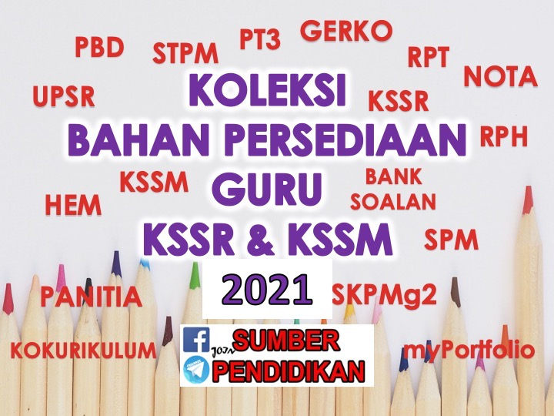

RPT SCIENCE YEAR 3 KSSR SEMAKAN
WEEK | CONTENT STANDARD | LEARNING STANDARD | NOTE
WEEK 1
1 Januari – 3 Januari 2021

WEEK 2
4 Januari – 10 Januari 2021

WEEK 3
11 Januari – 17 Januari 2021

WEEK 4  18 Januari – 24 Januari 2021 | 1.1 Science Process Skills | 1.1.1Observe  1.1.2 Classify  1.1.3 Measure and use numbers
WEEK 5  25 Januari – 31 Januari |  | 1.1.4 Make inference  1.1.5 Predict  1.1.6 Communicate
WEEK 6  1 Februari – 7 Februari 2021 | 1.2 Manipulative Skills | 1.2.1 Use and handle apparatus and science substances  correctly.  1.2.2 Handle specimens correctly and carefully.  1.2.3 Sketch specimens, apparatus and science  substances correctly.  1.2.4 Clean science apparatus correctly.  1.2.5 Store science apparatus and substances correctly  and safely.
WEEK 7  8 Februari – 14 Februari 2021 | 2.1 Science room rules | 2.1.1  Adhere to science room rules
WEEK 8  15 Februari – 21 Februari 2021 | 3.1 Teeth | 3.1.1 Describe the types of teeth and their functions.  3.1.2 Label the structure of the tooth.
WEEK 9  22 Februari – 28 Februari 2021 |  | 3.1.3 Compare and contrast sets of milk teeth and permanent  teeth.  3.1.4 Relate dental care with the structure of the tooth.  3.1.5 Explain the result of observations about teeth through written or verbal  forms, sketches or ICT in a creative way.
WEEK 10  1 Mac – 7 Mac 2021 | 3.2 Classes of food | 3.2.1 Give examples of food for each class of food.  3.2.2 Make generalisation about the importance of food  according to its class for the human body.
WEEK 11  8 Mac – 14 Mac 2021 |  | 3.2.3 Explain with examples of a balanced diet based on the  food pyramid.  3.2.4 Give reasons on the effects of imbalanced food intake.  3.2.5 Explain the result of observations about classes of food through written or verbal forms, sketches or ICT in a creative way.
WEEK 12  15 Mac – 21 Mac 2021 | 3.3 Digestion | 3.3.1 Describe the digestion process.  3.3.2 Arrange in sequence the flow of food during digestion.
WEEK 13  22 Mac – 28 Mac 2021 |  | 3.3.3 Conclude the digested food that is not required by the  body.  3.3.4 Explain the result of observations about digestion  through written or verbal forms, sketches or ICT in a creative way.
WEEK 14  29 Mac – 4 April 2021 | CUTI PERTENGAHAN PENGGAL 1
WEEK 15  5 April – 11 April 2021 | 4.1 Eating Habits | 4.1.1 Classify animals according to their eating habits
WEEK 16  12 April – 18 April 2021 |  | 4.1.2 Explain with examples the eating habits of herbivore,  carnivore and omnivore.
WEEK 17  19 April – 25 April 2021 |  | 4.1.3 Make inference about the animal groupings based on  their eating habits.
WEEK 18  26 April – 2 Mei 2021 |  | 4.1.4 Compare and constrast the dentition of herbivore,  carnivore and omnivore.
WEEK 19  3 Mei – 9 Mei 2021 |  | 4.1.5 Explain the result of observations about animals’  eating habits through written or verbal forms, sketches or ICT in a creative way.
WEEK 20  10 Mei – 16 Mei 2021 | 5.1 Plant Reproduction | 5.1.1 Give examples of plants for each way of reproduction.
WEEK 21  17 Mei – 23 Mei 2021 |  | 5.1.2 Give reasons on the importance of plant  reproduction to living things.
WEEK 22
24 Mei – 30 Mei 2021

WEEK 23  31 Mei – 6 Jun 2021 | CUTI PERTENGAHAN TAHUN
WEEK 24  7 Jun – 13 Jun 2021 | CUTI PERTENGAHAN TAHUN
WEEK 25  14 Jun – 20 Jun 2021 |  | 5.1.3 Make generalisation that a plant can reproduce through various ways by carrying out  projects.  5.1.4 Explain the result of observations about plant  reproduction through written or verbal forms, sketches or ICT in a creative way.
WEEK 26  21 Jun – 27 Jun 2021 | 6.1 Measurement of area and  volume. | 6.1.1 State the units that are used to measure area and volume.
WEEK 27  28 Jun – 4 Julai 2021 |  | 6.1.2 Measure the area of regular surfaces using 1cm x 1cm  square.
WEEK 28  5 Julai – 11 Julai 2021 |  | 6.1.3 Solve problems to estimate the area of irregular surfaces.
WEEK 29  12 Julai – 18 Julai 2021 |  | 6.1.4 Measure the volume of hollow boxes using 1cm x  1cm x 1cm cubes.
WEEK 30  19 Julai – 25 Julai 2021 | CUTI PERTENGAHAN PENGGAL 2
WEEK 31  26 Julai – 1 Ogos 2021 |  | 6.1.5 Measure the volume of liquid using correct tools and  techniques.  6.1.6 Solve problems to determine the volume of irregular  shaped solids using water displacement method.  6.1.7 Explain the result of observations about the  measurement of area and volume through written or verbal forms, sketches or ICT in a creative way.
WEEK 32  2 Ogos – 8 Ogos 2021 | 7.1 Objects or materials  which are more or less dense than water. | 7.1.1 Make inferences about objects or materials that  float or sink by carrying out activities.
WEEK 33  9 Ogos – 15 Ogos 2021 |  | 7.1.2 Relate objects or materials that float and objects or  materials that sink with density.
WEEK 34  16 Ogos – 22 Ogos 2021 |  | 7.1.3 Solve problems to identify methods to make water  more dense.  7.1.4 Explain the result of observations about object  or materials which are more or less dense through written or verbal forms, sketches or ICT in a creative way.
WEEK 35  23 Ogos – 29 Ogos 2021 | 8.1 Acid and alkali | 8.1.1 Test acidic, alkaline and neutral substances through  changes in colour of litmus paper by carrying out investigation.
WEEK 36  30 Ogos – 5 September 2021 |  | 8.1.2 Make generalisation on acidic, alkaline and neutral  substances through taste and touch by testing a few substances.
WEEK 37  6 September – 12 September 2021 |  | 8.1.3 Explore other materials to test acidic, alkaline and  neutral substances.  8.1.4 Explain the result of observations about acid and  alkali through written or verbal forms, sketches or ICT in a creative way.
WEEK 38  13 September – 19 September 2021 | CUTI PERTENGAHAN PENGGAL 2
WEEK 39  20 September – 26 September 2021 | 9.1 Solar System | 9.1.1 List member of the Solar System using various  media.
WEEK 40  27 September – 3 Oktober 2021 |  | 9.1.2 Make generalisation of the planets’ temperature based  on their sequence in the Solar System.  9.1.3 Describe the planets that revolve around the Sun on  their orbits.
WEEK 41  4 Oktober – 10 Oktober 2021 |  | 9.1.4 Relate the positions of the planets from the Sun with  the time taken for the planets to revolve around the Sun.  9.1.5 Explain the result of observations about Solar  System through written or verbal forms, sketches or ICT in a creative way.
WEEK 42  11 Oktober – 17 Oktober 2021 | 10.1 Pulley | 10.1.1 State the meaning and the uses of pulleys.
WEEK 43  18 Oktober– 24 Oktober 2021 |  | 10.1.2 Describe how a fixed pulley works using a  model.
WEEK 44  25 Oktober– 31 Oktober 2021 |  | 10.1.3 Give examples of the application of pulleys in  life.
WEEK 45  1 November – 7 November 2021 |  | 10.1.4 Create a functional model of a pulley.  10.1.5 Explain the result of observations about pulley  through written or verbal forms, sketches or ICT in a creative way.
WEEK 46
8 November – 14 November 2021

WEEK 47
15 November – 21 November 2021

WEEK 48
22 November – 28 November 2021

WEEK 49
29 November – 5 Disember 2021

WEEK 50
6 Disember – 12 Disember 2021

