PRAKATA
Alhamdulilllah, Terima kasih kepada rakan-rakan guru dan team sumberpendidikan kerana menyediakan RPT 2022/23 untuk kegunaan guru-guru di Malaysia.
Muaturun Percuma…
**DILARANG UNTUK MENGAMBIL SEBARANG BENTUK DAN JENIS KEUNTUNGAN DARIPADA PIHAK KAMI DAN WEB INI SAMA ADA SECARA LANGSUNG ATAU TIDAK LANGSUNG.**

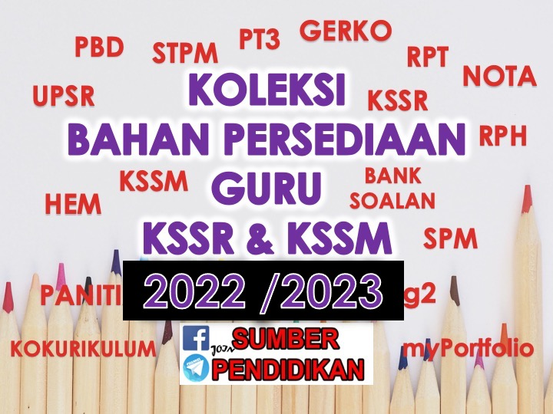

SCHEME OF WORK ENGLISH LANGUAGE FORM 3
YEAR 2022/23

WEEK | TYPES | LESSON | PAGE  (SOW) | THEME | UNIT  (CLOSE UP)
WEEK 1  21 March – 24 March 2022 | TB | 1, 2, 3 | 27 - 29 | People and Culture | Family Ties
WEEK 2  27 March – 31 March 2022 | TB | 4, 5, 6 | 30 - 32 | People and Culture | Family Ties
WEEK 3  3 April – 7 April 2022 | TB | 7, 8, 9 | 33 - 35 | People and Culture | Family Ties
WEEK 4  10 April – 14 April 2022  WEEK 5  17 April – 21 April  2022 | NTB | 10 | 36 | N/A | Teacher to select
 | TB | 11, 12 | 37 – 38 | People and Culture | Food,Food, Food!
WEEK 6  24 April – 28 April 2022 | TB | 13, 14, 15 | 39 - 41 | People and Culture | Food,Food, Food!
WEEK 7  1 May – 5 May 2022  WEEK 8  8 May – 12 May 2022 | TB | 16, 17 | 42 - 43 | People and Culture | Food,Food, Food!
WEEK 9  15 May – 19 May 2022 | TB | 18, 19, 20 | 44 – 45 | People and Culture | Food,Food, Food!
 | NTB | 20 | 46 | N/A | Teacher to select
WEEK 10  22 May – 26 May 2022 | TB | 21, 22, 23 | 47 – 49 | Health and Environment | The Wonders of Nature
WEEK 11  29 May – 2 June 2022 | TB | 24, 25, 26 | 50 - 52 | Health and Environment | The Wonders of Nature
WEEK 12
5 June – 11 June 2022

WEEK 13  12 June – 18 June 2022 | TB | 27, 28, 29 | 53 - 55 | Health and Environment | The Wonders of Nature
WEEK 14  19 – 25 June 2022  WEEK 15  26 June – 2 July 2022 | NTB | 30 | 56 | N/A | Teacher to select
 | TB | 31, 32 | 57 - 58 | Health and Environment | Special Relationships
WEEK 16  3 July – 9 July 2022 | TB | 33, 34, 35 | 59 - 61 | Health and Environment | Special Relationships
WEEK 17  10 July – 16 July 2022 | TB | 36, 37, 38 | 62 - 65 | Health and Environment | Special Relationships
WEEK 18  17 July – 23 July 2022 | TB | 39 | 65 | Health and Environment | Special Relationships
 | NTB | 40 | 66 | N/A | Teacher to select
WEEK 19  24 July – 30 July 2022 | TB | 41, 42, 43 | 67 - 69 | Science and Technology | A Place to Call Home
 | TB | 44, 45, 46 | 70 - 72 | Science and Technology | A Place to Call Home
WEEK 20  31 July – 6 August 2022 | TB | 47, 48, 49 | 73 - 75 | Science and Technology | A Place to Call Home
WEEK 21  7 August – 13 August 2022 | NTB | 50 | 76 | N/A | Teacher to select
 | TB | 51, 52 | 76 - 78 | Health and Environment | Ready, Steady, Go!
WEEK 22  14 August – 20 August 2022 | TB | 53, 54, 55 | 79 – 81 | Health and Environment | Ready, Steady, Go!
WEEK 23  21 August – 27 August 2022 | TB | 56, 57  (REVISION) | 82 | N/A | Teacher to select
 | TB | 58 | 83 | Health and Environment | Ready, Steady, Go!
WEEK 24
28 August – 3 September 2022
WEEK 25
4 Sept – 10 Sept 2022

WEEK 26  11 Sept – 17 Sept 2022 | TB | 59, 60 | 84 – 85 | Health and Environment | Ready, Steady, Go!
 | NTB | 61 | 86 | N/A | Teacher to select
WEEK 27  18 Sept – 24 Sept 2022 | TB | 62, 63, 64 | 87 – 89 | Health and Environment | Extreme Situations
WEEK 28  25 Sept – 1 October 2022 | TB | 65, 66, 67 | 90 – 92 | Health and Environment | Extreme Situations
WEEK 29  2 October – 8 October 2022 | TB | 68, 69, 70 | 93 - 95 | Health and Environment | Extreme Situations
WEEK 30  9 October – 15 October 2022 | NTB | 71 | 96 | N/A | Teacher to select
 | TB | 72, 73 | 97 – 98 | People and Culture | Time to Spare
WEEK 31  16 October – 22 October 2022 | TB | 74, 75 | 99–100 | People and Culture | Time to Spare
WEEK 32  23 October – 29 October 2022 | TB | 76, 77, 78 | 101-103 | People and Culture | Time to Spare
WEEK 33  30 October – 5 November 2022 | TB | 79, 80 | 104-105 | People and Culture | Time to Spare
 | NTB | 81 | 106 | N/A | Teacher to select
WEEK 34  6 November – 12 November 2022 | TB | 82, 83, 84 | 107-109 | Science and Technology | High-Tech World
WEEK 35  13 November –19 November 2022 | TB | 85, 86, 87 | 110-112 | Science and Technology | High-Tech World
WEEK 36  20 November – 26 November 2022 | TB | 88, 89, 90 | 113-115 | Science and Technology | High-Tech World
WEEK 37  27 November – 3 December 2022 | NTB | 91 | 116 | N/A | Teacher to select
 | TB | 92, 93 | 117-118 | People and Culture | That’s Entertainment
WEEK 38  4 December – 10 December 2022 | TB | 94, 95, 96 | 119-121 | People and Culture | That’s Entertainment
WEEK 39  11 December – 17 December 2022 |  |  |  |  | School Holiday 3
WEEK 40  18 December – 24 December 2022 |  |  |  |  | School Holiday 3
WEEK 41  25 December – 31 December 2022 |  |  |  |  | School Holiday 3
WEEK 42  1 January –7 January 2023 | TB | 97, 98, 99 | 122-124 | People and Culture | That’s Entertainment
WEEK 43  8 January – 14 January 2023 | TB | 100 | 125 | People and Culture | That’s Entertainment
 | NTB | 101 | 126 | N/A | Teacher to select
WEEK 44  15 January – 21 January 2023 | TB | 102, 103, 104 | 127-129 | People and Culture | Lessons to Learn
WEEK 45  22 January – 28 January 2023  WEEK 46  29 January – 4 February 2023 | TB | 105 | 130 | People and Culture | Lessons to Learn
 | TB/NTB | 106  (REVISION) | 131 | N/A | Teacher to select
 | TB | 107 | 132 | People and Culture | Lessons to Learn
WEEK 45  22 January – 28 January 2023 | NTB | 108 | 133 | N/A | Teacher to select
WEEK 46  29 January – 4 February 2023 | TB | 109, 110  (REVISION) | 134 - 135 | N/A | Teacher to select
WEEK 47  5 February – 11 February 2023 | NTB | 111 – 112  (PBL) | 136 | N/A | Teacher to select

*NTB = NON TEXTBOOK BASED LESSON, TB = TEXTBOOK BASED LESSON

