**Bahagian A**

[ *40 markah* ]

*Jawab* **semua** *soalan*

1. Maklumat berikut berkaitan dengan perkembangan idea nasionalisme di Barat.

|  |  |
| --- | --- |
| **Tahun** | **Peristiwa** |
| 1688 | Revolusi Keagungan |
| 1776 | Revolusi Amerika |
| 1789 | Revolusi Perancis |

(a) Mengapakah tercetusnya Revolusi Keagungan di England pada tahun 1688?

.................................................................................................................................................

................................................................................................................................................

................................................................................................................................................

.................................................................................................................................................

.................................................................................................................................................

.................................................................................................................................................

[ 3 *markah* ]

(b) Jelaskan reaksi orang Amerika terhadap penjajahan British.

.................................................................................................................................................

.................................................................................................................................................

.................................................................................................................................................

.................................................................................................................................................

.................................................................................................................................................

.................................................................................................................................................

[ 3 *markah* ]

(c) Maklumat berikut berkaitan rencana tentang perlunya pemimpin berwaspada terhadap kuasa asing.

MALAYSIA pernah dijajah oleh kuasa luar selama 446 tahun. Kesannya, segala sistem pemerintahan, politik, ekonomi dan sosial adalah sistem yang dibentuk penjajah. Sepanjang penjajahan, rakyat negara ini tidak mempunyai hak dalam mengendalikan urusan negara. Pengalaman yang pahit di bawah pengaruh dan penjajahan luar perlu dijadikan satu renungan oleh rakyat.

**Sumber:** Abd Rahman, Saodah (1998) Pemimpin Perlu Waspada Kebaikan Kuasa Asing. *Berita Harian*

Mengapakah kita perlu berhati-hati dengan pengaruh asing di negara kita?

.................................................................................................................................................

.................................................................................................................................................

.................................................................................................................................................

.................................................................................................................................................

.................................................................................................................................................

.................................................................................................................................................

.................................................................................................................................................

.................................................................................................................................................

.................................................................................................................................................

[ 4 *markah* ]

2. Komunisme ialah suatu fahaman politik yang disebarkan di negara kita oleh Parti Komunis Malaya (PKM) sejak tahun 1930-an.

(a) Nyatakan **dua** buah negara yang terlibat dengan penyebaran fahaman Komunis pada era 1920-an di Tanah Melayu.

(i) .....................................................................................................................................

(ii) .....................................................................................................................................

[ 2 *markah* ]

(b) Jelaskan tentang penubuhan Parti Komunis Malaya (PKM).

.................................................................................................................................................

.................................................................................................................................................

.................................................................................................................................................

................................................................................................................................................

................................................................................................................................................

................................................................................................................................................

[ 4 *markah* ]

(c) Petikan akhbar berikut berkaitan dengan ancaman Komunis di negara kita.

KUALA LUMPUR - Kerajaan dan rakyat Malaysia perlu sedar bahawa ancaman Komunis merupakan perkara yang sangat serius. Bekas Pengarah Jabatan Siasatan Jenayah Bukit Aman, Tan Sri Zaman Khan Rahim Khan berkata, tindakan tegas perlu diambil oleh kerajaan untuk memastikan ideologi Komunisme tidak berkembang di negara ini.

**Sumber**: *https://www.sinarharian.com.my/article/63316/berita/nasional/ancaman-komunis-serius-bukan-main-main*

Mengapakah ideologi Komunis perlu dihalang daripada berkembang di negara kita?

...............................................................................................................................................

...............................................................................................................................................

...............................................................................................................................................

...............................................................................................................................................

...............................................................................................................................................

................................................................................................................................................

.................................................................................................................................................

[ 4 *markah* ]

3. Rusuhan kaum yang berlaku pada 13 Mei 1969 merupakan tragedi hubungan antara kaum.

(a) Apakah faktor yang mencetuskan berlakunya peristiwa tersebut?

................................................................................................................................................

................................................................................................................................................

................................................................................................................................................

................................................................................................................................................

.................................................................................................................................................

[ 3 *markah* ]

(b) Perisytiharan darurat dibuat pada 16 Mei 1969 bagi menghentikan rusuhan kaum.

Apakah yang terkandung dalam perintah darurat tersebut?

.................................................................................................................................................

.................................................................................................................................................

.................................................................................................................................................

.................................................................................................................................................

.................................................................................................................................................

[ 3 *markah* ]

(c) “ Peristiwa 13 Mei memberi peringatan tentang kebenaran peribahasa ***kalah jadi abu, menang jadi arang*** kerana konflik itu merugikan semua kaum, selain menjejaskan imej negara di persada antarabangsa ," kata Felo utama Institut Kajian Etnik Universiti Kebangsaan Malaysia, Prof .Teo Kok Sing.

Ulaskan pernyataan tersebut.

..................................................................................................................................................................................................................................................................................................................................................................................................................................................

....................................................................................................................................................................................................................................................................................................................................................................................................................................................................................................................................................................................................

.................................................................................................................................................

.................................................................................................................................................

.................................................................................................................................................

.................................................................................................................................................

.................................................................................................................................................

[ 4 *markah* ]

4. Dasar Ekonomi Baru (DEB) telah berakhir pada tahun 1990. Dalam tempoh tersebut, ekonomi Malaysia berkembang pesat dan usaha DEB diteruskan dengan Dasar Pembangunan Nasional (DPN) .

(a) Apakah matlamat Dasar Pembangunan Nasional (DPN)?

.................................................................................................................................................

................................................................................................................................................

................................................................................................................................................

.................................................................................................................................................

[ 2 *markah* ]

(b) Jelaskan strategi pelaksanaan Dasar Pembangunan Nasional (DPN).

...................................................................................................................................................................................................................................................................................................................................................................................................................................................

...................................................................................................................................................................................................................................................................................................................................................................................................................................................

[ 4 *markah* ]

(c) Bagaimanakah Dasar Pembangunan Nasional (DPN) dapat membawa kemakmuran kepada pembangunan negara?

..................................................................................................................................................................................................................................................................................................................................................................................................................................................

................................................................................................................................................

.................................................................................................................................................

.................................................................................................................................................

[ 4 *markah* ]

**Bahagian B**

[ 60 *markah* ]

*Jawab mana-mana* **tiga** *soalan daripada bahagian ini.*

*Tulis jawapan anda pada ruang yang disediakan di* ***halaman 12*** *sehingga* ***halaman 19.***

5. Ketegangan hubungan antara kaum yang semakin meningkat selepas Perang Dunia Kedua membawa kepada penubuhan Jawatankuasa Hubungan Antara Kaum (CLC).

(a) Mengapakah Jawatankuasa Hubungan Antara Kaum (CLC) ditubuhkan?

[ 6 *markah* ]

(b) Jelaskan kejayaan Jawatankuasa Hubungan Antara Kaum (CLC) dalam menyelesaikan pelbagai isu yang melibatkan pertikaian kaum. [ 6 *markah* ]

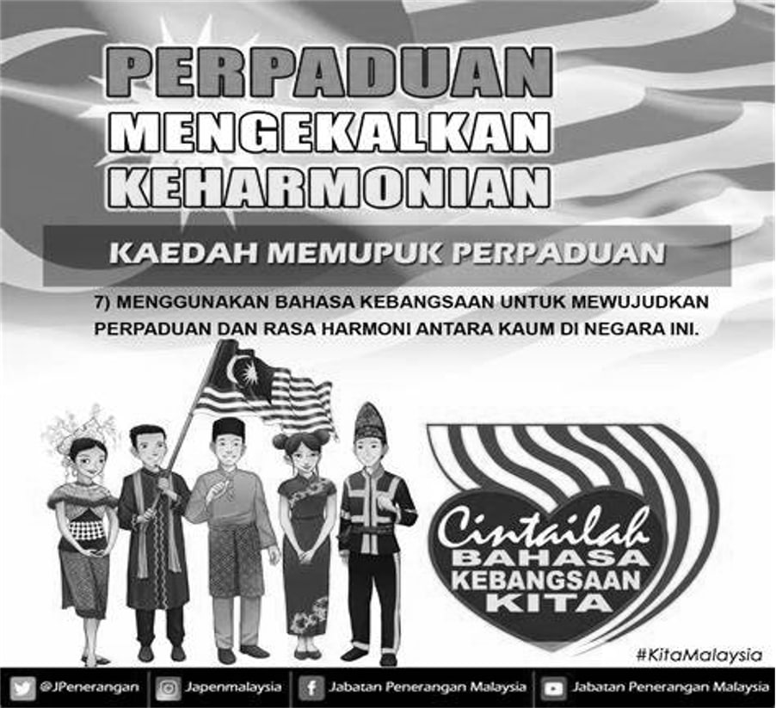 (c) Teliti poster tersebut.

Sumber:www.penerangan.gov.my

Huraikan mesej yang terkandung dalam poster tersebut. [ 8 *markah* ]

6. Upacara sambutan pemasyhuran kemerdekaan negara merupakan detik bersejarah yang dinantikan setelah melalui perjalanan yang panjang menuju kemerdekaan.

(a) Terangkan kronologi detik pemasyhuran kemerdekaan negara. [ 4 *markah* ]

(b) Huraikan peristiwa bersejarah di Stadium Merdeka. [ 8 *markah* ]

(c) Gambar berikut berkaitan dengan detik pemasyhuran kemerdekaan di Stadium

Merdeka pada 31 Ogos 1957.

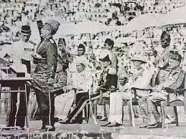

Tunku Abdul Rahman sedang membuat pemasyhuran kemerdekaan.

Berdasarkan gambar di atas, huraikan perasaan anda sekiranya berada di dalam majlis tersebut dan mengapakah anda berperasaan sedemikian? [ 8 *markah* ]

7. Perlembagaan Tanah Melayu 1957 menjadi asas kepada Perlembagaan Persekutuan Malaysia 1963.

(a) Mengapakah pindaan Perlembagaan 1963 dibuat? [ 4 *markah* ]

(b) Huraikan pindaan yang dibuat dalam Perlembagaan 1963. [ 8 *markah* ]

(c) Mengapakah pindaan perlembagaan perlu dilaksanakan pada hari ini? [ 8 *markah* ]

8. Pembentukan Sistem Persekutuan di negara kita bermula sejak tahun 1896. Sistem

Persekutuan telah memantapkan pentadbiran negara kita pada hari ini.

(a) Jelaskan konsep sistem Persekutuan di negara kita. [ 4 *markah* ]

(b) Terangkan peranan berikut:

(i) Pentadbiran Kerajaan Negeri [ 4 *markah* ]

(ii) Pentadbiran Kerajaan Pusat [ 4 *markah* ]

(c) Maklumat berikut berkaitan dengan kepentingan hubungan antara Kerajaan Persekutuan dan Kerajaan Negeri.

Kejayaan pemulihan ekonomi negara, kestabilan politik dan kesejahteraan sosial yang sedang dikecapi ketika ini, adalah hasil kerjasama Kerajaan Persekutuan dan Kerajaan Negeri yang sentiasa berganding bahu menyalurkan keperluan Keluarga Malaysia. Perdana Menteri, Datuk Seri Ismail Sabri Yaakob berkata, kerjasama erat itu adalah bagi memastikan tiada sesiapa pun yang tertinggal, seterusnya menangani jurang pendapatan dan membasmi kemiskinan. " Pandemik Covid-19 telah membawa impak yang besar ke atas kehidupan seharian Keluarga Malaysia dan kerajaan tidak pernah alpa dalam menyediakan bantuan dari segi kewangan, sosial mahupun peluang pekerjaan,” katanya . Dalam usaha membantu Keluarga Malaysia, Perdana Menteri berkata, kerajaan telah melakukan pelbagai inisiatif, antaranya menerusi Baucar Perlindungan Tenang, Satu Keluarga Satu Rumah, Transformasi Perkhidmatan Bas Berhenti-henti (SBST), selain penyediaan Rumah Mampu Milik dan jalur lebar tanpa wayar.

**Sumber**: [*https://www.sinarharian.com.my/article/191235/*](https://www.sinarharian.com.my/article/191235/)

*berita/nasional/kerjasama-persekutuan-negeri-pacu-pemulihan-ekonomi-kestabilan-politik*

Jelaskan maklumat yang anda peroleh daripada sumber di atas.

Mengapakah perlunya wujud hubungan baik antara Kerajaan Persekutuan dengan Kerajaan Negeri? [ 8 *markah* ]

9. Pelibatan Malaysia dalam negara serantau membolehkan negara kita menjadi anggota Persatuan Negara-negara Asia Tenggara (ASEAN).

(a) Terangkan latar belakang penubuhan ASEAN. [ 4 *markah* ]

(b) Jelaskan pelibatan Malaysia dalam kerjasama ekonomi dan sosial ASEAN. [ 8 *markah* ]

(c)

Negara anggota ASEAN kini berdepan pelbagai cabaran semasa termasuk ancaman keganasan militan, keselamatan maritim dan bencana alam, kata Ketua Setiausaha Kementerian Pertahanan, Datuk Seri Abdul Rahim Mohamad Radzi.

**Sumber**: https://www.bharian.com.my/berita/nasional/2016/09/195238/kerjasama-negara-asean-hadapi-ancaman-keganasan.

Jika anda sebagai pemimpin negara ASEAN, bagaimanakah anda mengatasi cabaran di atas?

Beri penjelasan anda. [ 8 *markah* ]

**KERTAS PEPERIKSAAN TAMAT**

............................................................................................................................................................

...................................................................................................................................................................................................................................................................................................................................................................................................................................................................................................................................................................................................................................................................................................................................................................................................................................................................................................................................................................................................................................................................................................................................

............................................................................................................................................................

....................................................................................................................................................................................................................................................................................................................................................................................................................................................................................................................................................................................................................................................................................................................................................................................................................................................................................................................................................................................................................................................................................................................................

............................................................................................................................................................

............................................................................................................................................................................................................................................................................................................................................................................................................................................................................................................................................................................................................................................................................................................................................................................................................................................................................................................................................................................................................................................................................................................................................................................................................................................................................................................................................................................................................................................................

..........................................................................................................................................................

....................................................................................................................................................................................................................................................................................................................................................................................................................................................................................................................................................................................................................................................................................................................................................................................................................................................................................................................................................................................................................................................................................................................................

...........................................................................................................................................................

....................................................................................................................................................................................................................................................................................................................................................................................................................................................................................................................................................................................................................................................................................................................................................................................................................................................................................................................................................................................................................................................................................................................................

............................................................................................................................................................

...................................................................................................................................................................................................................................................................................................................................................................................................................................................................................................................................................................................................................................................................................................................................................................................................................................................................................................................................................................................................................................................................................................................................

............................................................................................................................................................

....................................................................................................................................................................................................................................................................................................................................................................................................................................................................................................................................................................................................................................................................................................................................................................................................................................................................................................................................................................................................................................................................................................................................

............................................................................................................................................................

....................................................................................................................................................................................................................................................................................................................................................................................................................................................................................................................................................................................................................................................................................................................................................................................................................................................................................................................................................................................................................................................................................................................................

............................................................................................................................................................

....................................................................................................................................................................................................................................................................................................................................................................................................................................................................................................................................................................................................................................................................................................................................................................................................................................................................................................................................................................................................................................................................................................................................

...........................................................................................................................................................

...........................................................................................................................................................

....................................................................................................................................................................................................................................................................................................................................................................................................................................................................................................................................................................................................................................................................................................................................................................................................................................................................................................................................................................................................................................................................................................................................

...........................................................................................................................................................

....................................................................................................................................................................................................................................................................................................................................................................................................................................................................................................................................................................................................................................................................................................................................................................................................................................................................................................................................................................................................................................................................................................................................

............................................................................................................................................................

....................................................................................................................................................................................................................................................................................................................................................................................................................................................................................................................................................................................................................................................................................................................................................................................................................................................................................................................................................................................................................................................................................................................................

............................................................................................................................................................

............................................................................................................................................................

....................................................................................................................................................................................................................................................................................................................................................................................................................................................................................................................................................................................................................................................................................................................................................................................................................................................................................................................................................................................................................................................................................................................................

............................................................................................................................................................

....................................................................................................................................................................................................................................................................................................................................................................................................................................................................................................................................................................................................................................................................................................................................................................................................................................................................................................................................................................................................................................................................................................................................

............................................................................................................................................................

....................................................................................................................................................................................................................................................................................................................................................................................................................................................................................................................................................................................................................................................................................................................................................................................................................................................................................................................................................................................................................................................................................................................................

............................................................................................................................................................

............................................................................................................................................................

....................................................................................................................................................................................................................................................................................................................................................................................................................................................................................................................................................................................................................................................................................................................................................................................................................................................................................................................................................................................................................................................................................................................................

............................................................................................................................................................

....................................................................................................................................................................................................................................................................................................................................................................................................................................................................................................................................................................................................................................................................................................................................................................................................................................................................................................................................................................................................................................................................................................................................

............................................................................................................................................................

...................................................................................................................................................................................................................................................................................................................................................................................................................................................................................................................................................................................................................................................................................................................................................................................................................................................................................................................................................................................................................................................................................................................................

...........................................................................................................................................................

............................................................................................................................................................

...................................................................................................................................................................................................................................................................................................................................................................................................................................................................................................................................................................................................................................................................................................................................................................................................................................................................................................................................................................................................................................................................................................................................

............................................................................................................................................................

....................................................................................................................................................................................................................................................................................................................................................................................................................................................................................................................................................................................................................................................................................................................................................................................................................................................................................................................................................................................................................................................................................................................................

............................................................................................................................................................

....................................................................................................................................................................................................................................................................................................................................................................................................................................................................................................................................................................................................................................................................................................................................................................................................................................................................................................................................................................................................................................................................................................................................

............................................................................................................................................................

............................................................................................................................................................

........................................................................................................................................................................................................................................................................................................................................................................................................................................................................................................................................................................................................................................................................................................................................................................................................................................................................................................................................................................

........................................................................................................................................................................................................................................................................................................................................................................................................................................................................................................................................................................................................................................................................................................................................................................................................................................................................................................................................................................

........................................................................................................................................................................................................................................................................................................................................................................................................................................................................................................................................................................................................................................................................................................................................................................................................................................................................................................................................................................

........................................................................................................................................................................................................................................................................................................................................................................................................................................................................................................................................................................................................................................................................................................................................................................................................................................................................................................................................................................

............................................................................................................................................................