PERATURAN PERMARKAHAN

PEPERIKSAAN PERCUBAAN SPM TAHUN 2022

PRINSIP PERAKAUNAN

KERTAS 2
BAHAGIAN A

( 60 Markah )

Soalan
1. a. | i. Tidak terhad
 | ii. Terhad setakat sumbangan modal yang dilabur
b.
b. |  |  |  |  |  | Analisis Pembayaran
 |  | Tarikh | Butir | Pembayaran | Pos |  | Alat Tulis | Belanja
 |  | Tarikh | Butir | Pembayaran |  |  |  | Am
 |  |  |  |  | RM |  | RM | RM
 |  | 2022 |  | 12
 |  | Okt 5 | Faksimili | 12 | 12
 |  | 17 | Membaiki | 35
 |  |  | Komputer | 35 |  |  |  | 35
- Debit : Syarikat Halim

Kredit : Syarikat Haleem

- X = Dividen / Pindahan Kredit / Bayaran terlebih nilai dalam BT / Penerimaan terkurang

nilai dalam BT

Y = Caj Bank / Buku Cek / Cek Tak Layan / Faedah atas Overdraf / Bayaran terkurang nilai dalam BT / Penerimaan terlebih nilai dalam BT

- i. Kos Buruh Langsung ii. Kos Overhed

Markah

1

1

1

1

1

1

1

1

1

1

2 (a)

Perkongsian MS

Akaun Perdagangan dan Untung Rugi bagi tahun berakhir 31 Mac 2022

 |  | RM |  | RM |  |  | RM
Jualan |  |  |  |  |  | 90310
Tolak : Pulangan jualan |  |  |  |  |  | (2400)
Jualan Bersih |  |  |  |  |  |  | 87910 |  | 1
Inventori Awal |  |  |  | 28880
Belian | (50 240-150) | 50090 | 1
+ Angkutan masuk |  | 2 400 |  | 52490
Kos barang untuk dijual |  |  |  | 81370
(-) Inventori Akhir |  |  |  | (21560)
Kos Jualan |  |  |  |  |  | (59810) |  |  | 1of
Untung kasar |  |  |  |  |  | 28100 |  |  | 1+w
Tambah: Hasil
Diskaun |  |  |  | 870
Sewa (600x 12) |  |  |  | 7200 | 1 | 8070
 |  |  |  |  |  | 36170
Tolak:Belanja
Insurans |  |  |  | 5250
Kadar bayaran |  |  |  | 1800
Promosi |  |  |  | 1750
Hutang lapuk |  |  |  | 900 | 1
Pertambahan peruntukan Hutang Ragu |  |  |  | 150 | 1
[(8600-900) x 5%) - 235)]
Susut nilai Kenderaan (75000 x10%x 6/12) |  |  |  | 3750 | 1
Alat Tulis |  |  |  | 150 | 1
Penyelenggaraan |  |  |  | 500 | 1
Faedah atas pinjaman (40 000 x 6%) |  |  |  | 2400 | 1
 |  |  |  |  |  | (16650)
Untung bersih |  |  |  |  |  | 19520 |  |  | 1+w

12 markah

Syarat: 1of ada butiran Inventori Awal, Belian dan Inventori Akhir

1+w angka dan butiran betul

(b)

Perkongsian MS

Akaun Pengasingan Untung Rugi bagi tahun berakhir 31 Mac 2022

 |  |  |  | RM |  |  |  | RM
Untung bersih |  |  |  |  |  |  |  | 19520 |  | 1of (rujuk 2(a))
(-) Faedah atas modal |  |  |  | 9 000 |  |  | 1
Gaji Sufa |  |  |  | 24000 |  |  | 1
Elaun Mona |  |  |  | 800 |  |  | 1 | 33800
 |  |  |  |  |  |  |  | (14280)
(-) Akaun Semasa Mona(-14280 x 2/3) |  |  |  | (9520) |  |  | 1 of
Akaun Semasa Sufa (-14280 x 1/3) |  |  |  | (4760) |  |  | 1 of | (14280)
 |  |  |  |  |  |  |  | 0
 |  |  |  |  |  |  |  |  |  |  | [6 markah]
(c) |  |  | Akaun Semasa
 | Butiran | Mona | Sufa |  |  | Butiran |  |  | Mona |  | Sufa
 |  | RM | RM |  |  |  |  |  | RM
 | Baki b/b |  | 700 |  |  | Baki b/b |  |  | 1000
 | Gaji |  | 2000 |  | 1 | Faedah atas modal |  |  | 6 000 |  | 3 000 | 1
 | Pengasingan U Rugi | 9520 | 4760 |  | 1of | Elaun |  |  | 800
 | Baki h/b | 680 |  |  |  | Faedah atas |  |  | 2400 |  |  | 1
 |  |  |  |  |  | pinjaman
 |  |  |  |  |  | Baki h/b |  |  |  |  | 4460
 |  | 10200 | 7460 |  |  |  |  |  | 10200 |  | 7460
 | Baki b/b |  | 4460 |  |  | Baki b/b |  |  | 680


[4 markah]

(d)

Perkongsian MS

Penyata Kedudukan Kewangan pada 31 Mac 2022

 |  |  |  | RM |  |  | RM
 | Ekuiti Pemilik
 | Modal Mona (60000+500) |  |  | 60 500 | 1
 | Modal Sufa |  |  | 30 000
 |  |  |  |  | 90500 |  |  | 1 of
 | Akaun Semasa Mona |  |  | 680 |  |  | 1of
 | Akaun Semasa Sufa |  |  | (4460) |  |  | 1of
 |  |  |  |  | (3780)
 |  |  |  |  | 86720
 |  |  |  |  |  |  |  | [3 markah]
Syarat: 1of rujuk 2(c) dan ada modal setiap pekongsi
3(a)

 |  |  | Penyata Mengira Modal Pada 1 April 2021
 | Aset |  |  |  | RM |  |  |  | RM
 | Kenderaan (30000 – 3000) |  |  |  | 27 000 |  | 1
 | Lengkapan |  |  |  | 20 000
 | Inventori |  |  |  | 14 600
 | Akaun Belum Terima |  |  |  | 5 340
 | Bank |  |  |  | 8 400
 | Tunai |  |  |  | 1 250
 | Komisen Belum Terima |  |  |  | 1 200 |  |  |  | 77 790 |  | 1 of ( min. 5 butir tepat)
 | Tolak : Liabiliti
 | Akaun Belum Bayar |  |  |  | 10 870
 | Kadar Bayaran Belum Bayar |  |  |  | 375
 |  |  |  |  |  |  |  |  | (11 245) |  | 1
 | Modal Pada 1 April 2021 |  |  |  |  |  |  |  | 66 545 |  | 1
 |  |  |  |  |  |  |  |  |  |  |  | [ 4 markah ]
(b)
 |  |  | Penyata Mengira Modal Pada 31 Mac 2022
 | Aset |  |  |  |  |  | RM |  |  |  | RM
 | Kenderaan 30000 – [3000 + 10% x ( 30000 -3000) ] |  |  |  |  |  | 24 300 |  | 1 + 1of ( ada base = RM30000 )
 |  |  |  |  |  |  |  |  |  |  | ( min. 1 operasi tepat)
 | Lengkapan ( 20000 + 8000) – ( 10% x 20000) |  |  |  |  |  | 26 000 |  | 1 + 1of ( ada base = RM20000 )
 |  |  |  |  |  |  |  |  |  |  | ( min. 1 operasi tepat)
 | Inventori |  |  |  |  |  | 22 220
 | Akaun Belum Terima [7 280 – (7280 x 5%) ] |  |  |  |  |  | 6 916 |  | 1
 | Tunai |  |  |  |  |  | 950
 | Insurans Prabayar |  |  |  |  |  | 300 |  |  |  | 80 686 | 1 of ( semua butir
 |  |  |  |  |  |  |  |  |  |  |  | tepat)
 | Tolak : Liabiliti
 | Akaun Belum Bayar |  |  |  |  |  | 12 700
 | Bank |  |  |  |  |  | 1 350
 | Kadar Bayaran Belum Bayar |  |  |  |  |  | 260
 |  |  |  |  |  |  |  |  |  |  | (14 310) | 1
 | Modal Pada 31 Mac 2022 |  |  |  |  |  |  |  |  |  | 66 376 | 1
 |  |  |  |  |  |  |  |  |  |  |  | [ 8 markah ]

(c)

Penyata Untung Rugi Bagi Tahun Berakhir 31 Mac 2022

 | RM | RM
Modal Akhir |  | 66 376 | 1 of [ rujuk 3(b) ]
(+) Ambilan |  | 1 500 | 1
 |  | 67 876
(-) Modal Tambahan | 8 000 |  | 1
 |  | 74 545
Modal Awal | 66 545 | 75 545 | 1 of [ rujuk 3(a) ]
Rugi Bersih |  | (6669) | 1 + word

[ 5 markah ]

(d)

Penyata Kedudukan Kewangan Pada 31 Mac 2022

 |  |  |  |  |  | RM | RM | RM
 | Aset Bukan Semasa |  |  |  |  | Kos | SNT | Nilai Buku
 | Kenderaan |  |  |  |  | 30 000 | 5 700 | 24 300
 | Lengkapan |  |  |  |  | 28 000 | 2 000 | 26 000
 |  |  |  |  |  |  |  | 50 300 | 1
 | Aset Semasa
 | Inventori |  |  |  |  |  | 22 220
 | Akaun Belum Terima |  |  |  |  |  | 6916
 | Tunai |  |  |  |  |  | 950
 | Insurans Prabayar |  |  |  |  |  | 300
 |  |  |  |  |  |  | 30 386
 | Tolak : Liabiliti Semasa
 | Akaun Belum Bayar |  |  |  |  | 12 700
 | Bank |  |  |  |  | 1 350
 | Kadar Bayaran Belum Bayar |  |  |  |  | 260 | (14 310)
 | Modal Kerja |  |  |  |  |  |  | 16 076 | 1+1of + W ( operasi tepat)
 |  |  |  |  |  |  |  | 66 376
 | Ekuiti Pemilik
 | Modal Awal |  |  |  |  |  |  | 66 545
 | (-) Rugi Bersih |  |  |  |  |  |  | (6669) | 1 of [ rujuk 3 (c)]
 |  |  |  |  |  |  |  | 59 876
 | (+) Modal Tambahan |  |  |  |  |  |  | 8 000
 |  |  |  |  |  |  |  | 67 876
 | (-) Ambilan |  |  |  |  |  |  | (1 500)
 | Modal Akhir |  |  |  |  |  |  | 66 376 | fb1
 |  |  |  |  |  |  |  |  | [ 5 markah ]

(e) |  |  | Akaun Modal
2022 |  | RM | 2022 |  | RM
Mac 31 | Ambilan | 1 500 | Mac 31 | Baki b/b | 66 545
 | Rugi Bersih | 6 669 | 1fb | Lengkapan | 8 000 | 1
 | Baki h/b | 66 376
 |  | 74 545 |  |  | 74 545
 |  |  | April 1 | Baki b/b | 66 376 | 1fb
 |  |  |  |  |  | [ 3 markah]

- a)(i)(i). Dividen Interim Syer Keutamaan

  - 1 000 000 x RM1.00 x 6% x 6/12 bulan

  - RM30 000

( 2 Markah)

Dividen Interim Syer Biasa

= 2 000 000 x RM0.50 x 3%

=RM30 000

 |  |  |  |  | ( 2 Markah)
ii.
ii. | Tahun | Dividen Syer Keutamaan |  | Dividen Syer Biasa
 | 2018 | =RM3 000 000 x 6% |  | =RM300 000 – RM180 000
 |  | =RM180 000 | (1) | =RM120 000 | ( 1 )
 | 2019 | Tiada | (1fb) | Tiada
 | 2020 | =RM180 000 x 2 |  | Tiada
 |  | =RM360 000 | (1)
 | 2021 | =RM3 000 000 x 6% |  | =RM500 000 – RM180 000
 |  | =RM180 000 | (1) | =RM320 000 | (1)

b(i)

ii)
Akaun Yuran
2021 |  |  |  | RM |  | 2021 | RM
Jan 1 | Yuran belum |  | 625 |  | (1) | Dis 31 Bank | 6 520 (1)
 | terima
Dis | Pendapatan |  | 5 460 |  | (1)
31 | dan
31 | Perbelanjaan
 | Yuran belum |  | 435 |  | (1)
 | terperoleh
 |  |  |  | 6 520 |  |  | 6 520

Kelab Bola Keranjang Ipoh

Akaun Pendapatan dan Perbelanjaan bagi tahun berakhir

31 Disember 2021

 | RM |  |  | RM
Gaji dan imbuhan | 8 200 |  | Yuran Ahli | 5 460 | (1of)
Kadar bayaran | 1 250 | (1) | Sewa Gelanggang | 8 000 | (1)
(1500 -250) |  |  | (8500-500)
Susut nilai Perabot | 2 170 | (1of) | Untung Pertandingan | 2 800 | (1)
(20 530 +3 000 -21 |  |  | (6 000 – 3 200)
360)
Lebihan | 4 640 | (1of)
 | 16 260 |  |  | 16 260

5(a) |  |  |  | BUKU TUNAI
TARIKH | BUTIR | Diskaun | TUNAI | BANK | TARIKH | BUTIR | Diskaun | TUNAI | BANK
TARIKH | BUTIR | diberi | (RM) | (RM) | TARIKH | BUTIR | Diterima | (RM) | (RM)
2022 |  |  |  |  | 2022
Mei 1 | Baki b/b | 1fb | 2000 | 3000 | Mei 8 | Jasmine | 40 (1) |  | 900(1)
12 | Kedai Chin Chin | 50(1) |  | 650(1) | 16 | Utiliti |  | 300(1)
30 | Tunai(k) |  |  | 1200(1) | 28 | Kedai Chin Chin |  |  | 650(1)
 |  |  |  |  | 30 | Bank(k) |  | 1200(1)
 |  |  |  |  | 31 | Baki h/b |  | 500 | 3300
 |  | 50 | 2000 | 4850 |  |  | 40 | 2000 | 4850
Jun 1 | Baki b/b |  | 500 | 3300

 |  |  |  | 1 fb of
5(b) |  |  | JADUAL PERSAMAAN PERAKAUNAN
 |  |  |  |  |  |  |  |  |  |  |  |  |  | Untung
Baki | Perabot |  | Akaun belum terima |  | Inventori |  | Bank |  |  | Akaun belum Bayar |  | Modal |  | Bersih
Baki | 4 600 |  | 3080 |  | 8700 |  | 7130 |  |  | 3510 |  | 20000 | 1
(a) |  |  | 780 | 1 | -540 | 1 |  |  |  |  |  |  |  | 240 | 1
(b) | 760 |  |  |  |  |  |  |  |  |  |  | 760 |  |  | 1 fb
(c) |  |  | 440 | 1 |  |  | -440 |  | 1
(d) |  |  | -80 | 1 | 80 | 1
(e) |  |  |  |  |  |  | -880 |  |  |  |  |  |  | -880 | 1fb
 | 5360 |  | 4220 |  | 8240 |  | 5810 |  |  | 3510 |  | 20760 |  | -640

6(a)
(a) | Pengiraan |  |  |  |  |  |  |  |  |  |  |  |  |  |  |  |  | Markah
(i) | Kos berubah seunit =200 000 – 100 000 = 100 000 = RM50 |  |  |  |  |  |  |  |  |  |  |  |  |  |  |  |  | (2m)
 |  |  |  |  |  |  |  |  |  |  |  |  | 2 000
(ii) | Titik pulang modal = Kos Tetap = |  |  |  |  |  |  |  |  |  |  | RM100 000= |  |  |  |  | 5 000 unit | (2m)
 |  |  | Margin caruman seunit |  |  |  |  |  |  |  | (RM70 – RM50)
(iii) | TPM= 100 000 + 30 000 = 6 500 unit |  |  |  |  |  |  |  |  |  |  |  |  |  |  |  |  | (2m)
 |  |  | RM20
(iv) | TPM = 100 000 - 10%(100 000) = 4 500 unit |  |  |  |  |  |  |  |  |  |  |  |  |  |  |  |  | (2m)
 |  |  | RM20

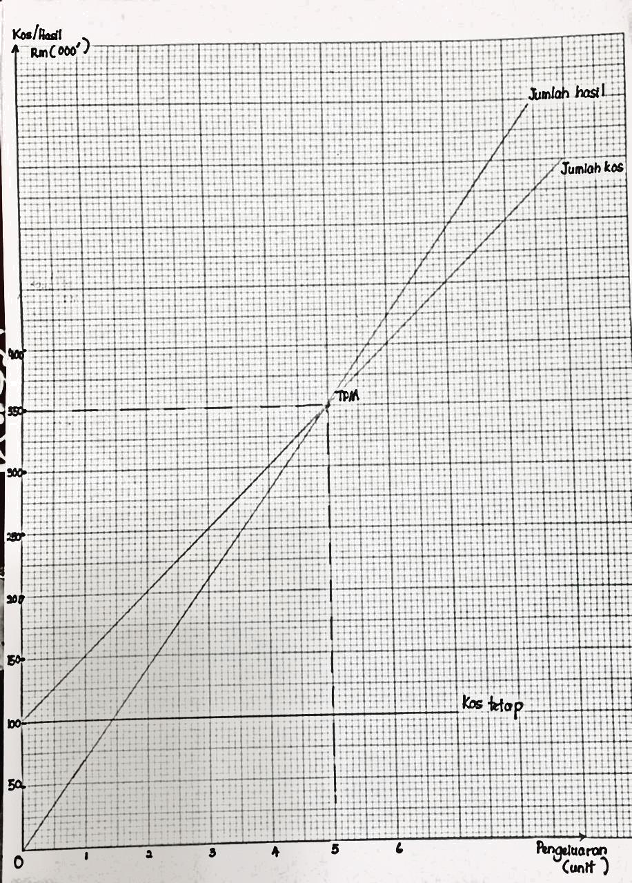  (b) | (4m)

(b)
(i)PHR 2021 = (35600-500) X 4% = 1404 |  | (2m)
 | PHR 2022 = (42800-700) X 3% = 1263 | (2m)
(ii) | AKAUN PERUNTUKAN HUTANG RAGU

2021 |  | RM
Dis 31 | Baki h/b | 1 404
 |  | 1 404
2022
Dis 31 | Baki h/b | 1 263
 | Untung
 | Rugi | 141
 |  | 1 404

 | 2021 |  | RM
Jan | 1 | Baki b/b | 726
Dis | 31 | Untung Rugi | 678 | (2m)
 |  |  | 1 404
 | 2022
 | Jan-01 | Baki b/b | 1 404
 |  |  |  | (2m)
 |  |  | 1 404

