PRAKATA
Alhamdulilllah, Terima kasih kepada rakan-rakan guru dan team sumberpendidikan kerana menyediakan RPT 2023/2024 untuk kegunaan guru-guru di Malaysia.
Muaturun Percuma…
**DILARANG UNTUK MENGAMBIL SEBARANG BENTUK DAN JENIS KEUNTUNGAN DARIPADA PIHAK KAMI DAN WEB INI SAMA ADA SECARA LANGSUNG ATAU TIDAK LANGSUNG.**

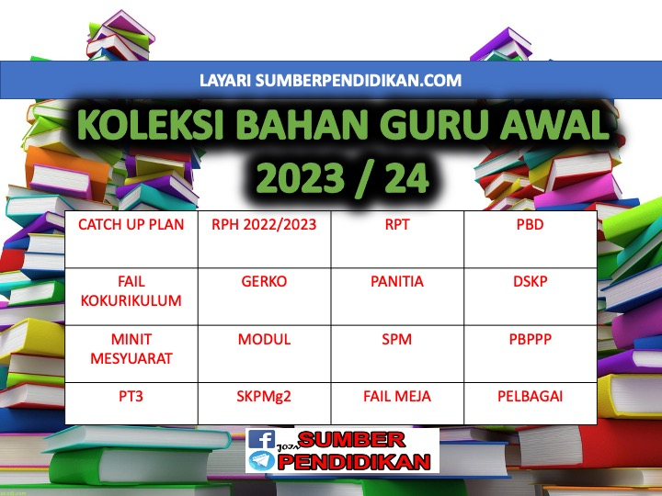

SCHEME OF WORK ENGLISH LANGUAGE FORM 3
YEAR 2023/2024

WEEK | TYPES | LESSON | PAGE  (SOW) | THEME | UNIT  (CLOSE UP)
WEEK 1  KUMPULAN A  19 March – 23 March 2024  KUMPULAN B  20 March – 24 March 2024 | TB | 1, 2, 3 | 27 - 29 | People and Culture | Family Ties
WEEK 2  KUMPULAN A  26 March – 30 March 2023  KUMPULAN B  27 March – 31 March 2023 | TB | 4, 5, 6 | 30 - 32 | People and Culture | Family Ties
WEEK 3  KUMPULAN A  2 April – 6 April 2023  KUMPULAN B  3 April – 7 April 2023 | TB | 7, 8, 9 | 33 - 35 | People and Culture | Family Ties
WEEK 4  KUMPULAN A  9 April – 13 April 2023  KUMPULAN B  10 April – 14 April 2023  WEEK 5  KUMPULAN A  16 April – 20 April  KUMPULAN B  17 April – 21 April | NTB | 10 | 36 | N/A | Teacher to select
 | TB | 11, 12 | 37 – 38 | People and Culture | Food,Food, Food!
KUMPULAN A  23 April – 27 April 2023  KUMPULAN B  24 April – 28 April 2023 | Cuti Pertengahan Penggal 1
WEEK 6  KUMPULAN A  30 April – 4 May 2023  KUMPULAN B  1 May – 5 May 2023 | TB | 13, 14, 15 | 39 - 41 | People and Culture | Food,Food, Food!
WEEK 7  KUMPULAN A  7 May – 11 May 2023  KUMPULAN B  8 May – 12 May 2023  WEEK 8  KUMPULAN A  14 May – 18 May 2023  KUMPULAN B  15 May – 19 May 2023 | TB | 16, 17 | 42 - 43 | People and Culture | Food,Food, Food!
WEEK 9  KUMPULAN A  21 May – 25 May 2023  KUMPULAN B  22 May – 26 May 2023 | TB | 18, 19, 20 | 44 – 45 | People and Culture | Food,Food, Food!
 | NTB | 20 | 46 | N/A | Teacher to select
KUMPULAN A  28 May – 1 June 2023  KUMPULAN B  29 May – 2 June 2023 | Cuti Penggal 1
WEEK 10  KUMPULAN A  4 June – 8 June 2023  KUMPULAN B  5 June – 9 June 2023 | TB | 21, 22, 23 | 47 – 49 | Health and Environment | The Wonders of Nature
WEEK 11  KUMPULAN A  11 June – 15 June 2023  KUMPULAN B  12 June – 16 June 2023 | TB | 24, 25, 26 | 50 - 52 | Health and Environment | The Wonders of Nature
WEEK 12  KUMPULAN A  18 – 22 June 2023  KUMPULAN B  19 – 23 June 2023 | TB | 27, 28, 29 | 53 - 55 | Health and Environment | The Wonders of Nature
WEEK 13  KUMPULAN A  25 June – 29 June 2023  KUMPULAN B  26 June – 30 June 2023  WEEK 14  KUMPULAN A  2 July – 6 July 2023  KUMPULAN B  3 July – 7 July 2023 | NTB | 30 | 56 | N/A | Teacher to select
 | TB | 31, 32 | 57 - 58 | Health and Environment | Special Relationships
WEEK 15  KUMPULAN A  9 July – 13 July 2023  KUMPULAN B  10 July – 14 July 2023 | TB | 33, 34, 35 | 59 - 61 | Health and Environment | Special Relationships
WEEK 16  KUMPULAN A  16 July – 20 July 2023  KUMPULAN B  17 July – 21 July 2023 | TB | 36, 37, 38 | 62 - 65 | Health and Environment | Special Relationships
WEEK 17  KUMPULAN A  23 July – 27 July 2023  KUMPULAN B  24 July – 28 July 2023 | TB | 39 | 65 | Health and Environment | Special Relationships
 | NTB | 40 | 66 | N/A | Teacher to select
WEEK 18  KUMPULAN A  30 July – 3 August 2023  KUMPULAN B  31 July – 4 August 2023 | TB | 41, 42, 43 | 67 - 69 | Science and Technology | A Place to Call Home
WEEK 19  KUMPULAN A  6 August – 10 August 2023  KUMPULAN B  7 August – 11 August 2023 | TB | 44, 45, 46 | 70 - 72 | Science and Technology | A Place to Call Home
WEEK 20  KUMPULAN A  13 August – 17 August 2023  KUMPULAN B  14 August – 18 August 2023 | TB | 47, 48, 49 | 73 - 75 | Science and Technology | A Place to Call Home
WEEK 21

KUMPULAN A
20 August – 24 August 2023

KUMPULAN B
21 August – 25 August 2023
KUMPULAN A  27 August – 31 August 2023  KUMPULAN B  28 August – 1 Sept 2023 | Cuti Penggal 2
WEEK 22  KUMPULAN A  3 Sept – 7 Sept 2023  KUMPULAN B  4 Sept – 8 Sept 2023  WEEK 23  KUMPULAN A  10 Sept – 14 Sept 2023  KUMPULAN B  11 Sept – 15 Sept 2023 | NTB | 50 | 76 | N/A | Teacher to select
 | TB | 51, 52 | 76 - 78 | Health and Environment | Ready, Steady, Go!
WEEK 24  KUMPULAN A  17 Sept – 21 Sept 2023  KUMPULAN B  18 Sept – 22 Sept 2023 | TB | 53, 54, 55 | 79 – 81 | Health and Environment | Ready, Steady, Go!
WEEK 22  KUMPULAN A  3 Sept – 7 Sept 2023  KUMPULAN B  4 Sept – 8 Sept 2023 | TB | 56, 57  (REVISION) | 82 | N/A | Teacher to select
 | TB | 58 | 83 | Health and Environment | Ready, Steady, Go!
WEEK 25  KUMPULAN A  24 Sept – 28 Sept 2023  KUMPULAN B  25 Sept – 29 Sept 2023 | TB | 59, 60 | 84 – 85 | Health and Environment | Ready, Steady, Go!
 | NTB | 61 | 86 | N/A | Teacher to select
WEEK 26  KUMPULAN A  1 Oktober – 5 Oktober 2023  KUMPULAN B  2 Oktober – 6 Oktober 2023 | TB | 62, 63, 64 | 87 – 89 | Health and Environment | Extreme Situations
WEEK 27  KUMPULAN A  8 Oktober – 12 Oktober 2023  KUMPULAN B  9 Oktober – 13 Oktober 2023 | TB | 65, 66, 67 | 90 – 92 | Health and Environment | Extreme Situations
WEEK 28  KUMPULAN A  15 Oktober – 19 Oktober 2023  KUMPULAN B  16 Oktober – 20 Oktober 2023 | TB | 68, 69, 70 | 93 - 95 | Health and Environment | Extreme Situations
WEEK 29  KUMPULAN A  22 Oktober – 26 Oktober 2023  KUMPULAN B  23 Oktober – 27 Oktober 2023 | NTB | 71 | 96 | N/A | Teacher to select
 | TB | 72, 73 | 97 – 98 | People and Culture | Time to Spare
WEEK 30  KUMPULAN A  29 Oktober – 2 November 2023  KUMPULAN B  30 Oktober – 3 November 2023 | TB | 74, 75 | 99–100 | People and Culture | Time to Spare
WEEK 31  KUMPULAN A  5 November – 9 November 2023  KUMPULAN B  6 November – 10 November 2023 | TB | 76, 77, 78 | 101-103 | People and Culture | Time to Spare
WEEK 32  KUMPULAN A  12 November –16 November 2023  KUMPULAN B  13 November –17 November 2023 | TB | 79, 80 | 104-105 | People and Culture | Time to Spare
 | NTB | 81 | 106 | N/A | Teacher to select
WEEK 33  KUMPULAN A  19 November – 23 November 2023  KUMPULAN B  20 November – 24 November 2023 | TB | 82, 83, 84 | 107-109 | Science and Technology | High-Tech World
WEEK 34  KUMPULAN A  26 November – 30 November 2023  KUMPULAN B  27 November – 1 December 2023 | TB | 85, 86, 87 | 110-112 | Science and Technology | High-Tech World
WEEK 35  KUMPULAN A  3 December – 7 December 2023  KUMPULAN B  4 December – 8 December 2023 | TB | 88, 89, 90 | 113-115 | Science and Technology | High-Tech World
WEEK 36  KUMPULAN A  10 December – 14 December 2023  KUMPULAN B  11 December – 15 December 2023 | NTB | 91 | 116 | N/A | Teacher to select
 | TB | 92, 93 | 117-118 | People and Culture | That’s Entertainment
KUMPULAN A  17 December – 21 December 2023  KUMPULAN B  18 December – 22 December 2023 | Cuti Penggal 3
KUMPULAN A  24 December – 28 December 2023  KUMPULAN B  25 December – 29 December 2023 | Cuti Penggal 3
WEEK 37  KUMPULAN A  31 December –4 January 2024  KUMPULAN B  1 January –5 January 2024 | TB | 94, 95, 96 | 119-121 | People and Culture | That’s Entertainment
WEEK 38  KUMPULAN A  7 January – 11 January 2024  KUMPULAN B  8 January – 12 January 2024 | TB | 97, 98, 99 | 122-124 | People and Culture | That’s Entertainment
WEEK 39  KUMPULAN A  14 January – 18 January 2024  KUMPULAN B  15 January – 19 January 2024 | TB | 100 | 125 | People and Culture | That’s Entertainment
 | NTB | 101 | 126 | N/A | Teacher to select
 | TB | 102, 103, 104 | 127-129 | People and Culture | Lessons to Learn
WEEK 40  KUMPULAN A  21 January – 25 January 2024  KUMPULAN B  22 January – 26 January 2024 | TB | 105 | 130 | People and Culture | Lessons to Learn
 | TB/NTB | 106  (REVISION) | 131 | N/A | Teacher to select
 | TB | 107 | 132 | People and Culture | Lessons to Learn
 | NTB | 108 | 133 | N/A | Teacher to select
WEEK 41  KUMPULAN A  28 January – 1 February 2024  KUMPULAN B  29 January – 2 February 2024 | TB | 109, 110  (REVISION) | 134 - 135 | N/A | Teacher to select
 | NTB | 111 – 112  (PBL) | 136 | N/A | Teacher to select

*NTB = NON TEXTBOOK BASED LESSON, TB = TEXTBOOK BASED LESSON

