PRAKATA
Alhamdulilllah, Terima kasih kepada rakan-rakan guru dan team sumberpendidikan kerana menyediakan RPT 2023/2024 untuk kegunaan guru-guru di Malaysia.
Muaturun Percuma…
**DILARANG UNTUK MENGAMBIL SEBARANG BENTUK DAN JENIS KEUNTUNGAN DARIPADA PIHAK KAMI DAN WEB INI SAMA ADA SECARA LANGSUNG ATAU TIDAK LANGSUNG.**
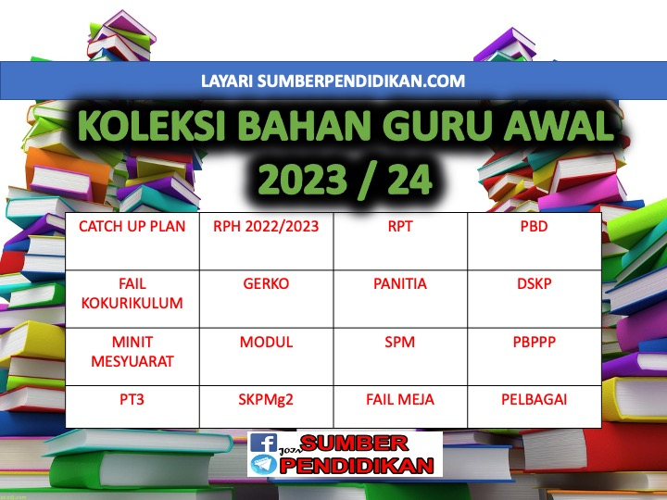

WEEK | CONTENT STANDARD | LEARNING STANDARD | NOTE
WEEK 1  KUMPULAN A  19 March – 23 March 2024  KUMPULAN B  20 March – 24 March 2024 |  | TRANSITION WEEK
WEEK 2  KUMPULAN A  26 March – 30 March 2023  KUMPULAN B  27 March – 31 March 2023 |  | TRANSITION WEEK
WEEK 3  KUMPULAN A  2 April – 6 April 2023  KUMPULAN B  3 April – 7 April 2023 |  | TRANSITION WEEK
WEEK 4  KUMPULAN A  9 April – 13 April 2023  KUMPULAN B  10 April – 14 April 2023 | 1.1 Science Process Skills | Pupils are able to:  - Observe  1.1.2 Communicate
WEEK 5  KUMPULAN A  16 April – 20 April  KUMPULAN B  17 April – 21 April | 1.2 Manipulative Skills | 1.2.1 Use and handle science apparatus and substances correctly.  1.2.2 Handle specimens correctly and carefully.  1.2.3 Sketch specimens, apparatus and science substances correctly.  1.2.4 Clean science apparatus correctly.  1.2.5 Store science apparatus and substances correctly and safely.
KUMPULAN A  23 April – 27 April 2023  KUMPULAN B  24 April – 28 April 2023 | Cuti Pertengahan Penggal 1
WEEK 6  KUMPULAN A  30 April – 4 May 2023  KUMPULAN B  1 May – 5 May 2023 | 2.1 Science room rules | 2.1.1 Adhere to science room rules
WEEK 7  KUMPULAN A  7 May – 11 May 2023  KUMPULAN B  8 May – 12 May 2023 | 3.1 Living things and non-living things | 3.1.1  Compare and contrast living things and non-living things based on the following characteristics:  (i) breathe;  (ii) need food and water;  (iii) move;  (iv) grow; and  (v) reproduce.
WEEK 8  KUMPULAN A  14 May – 18 May 2023  KUMPULAN B  15 May – 19 May 2023 |  | 3.1.2 Arrange in sequence the examples of living things based on their sizes
WEEK 9  KUMPULAN A  21 May – 25 May 2023  KUMPULAN B  22 May – 26 May 2023 | 3.2 Basic needs of living things | 3.2.1 State the basic needs of living things i.e. food, water and air.  3.2.2 Describe human, animals and plants need food, water and air in different ways.
KUMPULAN A  28 May – 1 June 2023  KUMPULAN B  29 May – 2 June 2023 | Cuti Penggal 1
WEEK 10  KUMPULAN A  4 June – 8 June 2023  KUMPULAN B  5 June – 9 June 2023 |  | 3.2.3 Describe human and animals also need shelters.  3.2.4 Provide reasoning on the importance of food, water, air and shelter to human and animals.  3.2.5 Explain observations on characteristics and basic needs of living things using sketches, ICT, writing or verbally.
WEEK 11  KUMPULAN A  11 June – 15 June 2023  KUMPULAN B  12 June – 16 June 2023 | 4.1 Human senses | 4.1.1 Identify parts of human body which related to senses.  4.1.2 Classify the objects according to identified characteristic.
WEEK 12  KUMPULAN A  18 – 22 June 2023  KUMPULAN B  19 – 23 June 2023 |  | 4.1.3 Use senses to identify objects through investigation.  4.1.4 Explain with examples, use other senses if one of the  senses is not functioning.  4.1.5 Explain observations about human senses using sketches, ICT, writing or  verbally.
WEEK 13  KUMPULAN A  25 June – 29 June 2023  KUMPULAN B  26 June – 30 June 2023 | 5.1 Parts of animals | 5.1.1 Identify the parts of animals e.g. beak, scales, fins, fine hair, feathers, horn, feelers, hard skin, shell, wings, head,  body, tail and webbed feet.
WEEK 14  KUMPULAN A  2 July – 6 July 2023  KUMPULAN B  3 July – 7 July 2023 |  | 5.1.2 Relate the parts of animals with their importance.  5.1.3 Explain through examples the parts of animals.
WEEK 15  KUMPULAN A  9 July – 13 July 2023  KUMPULAN B  10 July – 14 July 2023 |  | 5.1.4 Make generalisation that different animals may have  same parts of the body.
WEEK 16  KUMPULAN A  16 July – 20 July 2023  KUMPULAN B  17 July – 21 July 2023 |  | 5.1.5 Explain observations about parts of animals using sketches, ICT, writing or  verbally.
WEEK 17  KUMPULAN A  23 July – 27 July 2023  KUMPULAN B  24 July – 28 July 2023 | 6.1 Parts of plants | 6.1.1 Compare and contrast parts of plant i.e.:  (i) leaf: types of vein;  (ii) flower: flowering, non-  flowering;  (iii) stem: woody, non-  woody; and  (iv) root: tap root, fibre root.
WEEK 18  KUMPULAN A  30 July – 3 August 2023  KUMPULAN B  31 July – 4 August 2023 |  | 6.1.2 Relate the parts of plants i.e. leaf, flower, stem and root with  its importance to the plant.
WEEK 19  KUMPULAN A  6 August – 10 August 2023  KUMPULAN B  7 August – 11 August 2023 |  | 6.1.3 Make generalisation that different plants may have same  parts.
WEEK 20  KUMPULAN A  13 August – 17 August 2023  KUMPULAN B  14 August – 18 August 2023 |  | 6.1.4 Explain observations about parts of plants using sketches,  ICT, writing or verbally.
WEEK 21

KUMPULAN A
20 August – 24 August 2023

KUMPULAN B
21 August – 25 August 2023
KUMPULAN A  27 August – 31 August 2023  KUMPULAN B  28 August – 1 Sept 2023 | Cuti Penggal 2
WEEK 22  KUMPULAN A  3 Sept – 7 Sept 2023  KUMPULAN B  4 Sept – 8 Sept 2023 | 7.1 Magnet | 7.1.1 Give examples the usage of magnets in daily life.  7.1.2 Identify the shapes of magnets e.g. bar, cylinder, horseshoe, U-shaped, button  and ring.
WEEK 23  KUMPULAN A  10 Sept – 14 Sept 2023  KUMPULAN B  11 Sept – 15 Sept 2023 |  | 7.1.3 Make generalisation on reactions of magnets to various objects by carrying  out activities.
WEEK 24  KUMPULAN A  17 Sept – 21 Sept 2023  KUMPULAN B  18 Sept – 22 Sept 2023 |  | 7.1.4 Conclude that magnet attracts or repels between two poles investigation.  through
WEEK 25  KUMPULAN A  24 Sept – 28 Sept 2023  KUMPULAN B  25 Sept – 29 Sept 2023 |  | 7.1.5 Determine the strengths of magnet towards object  through investigation.  7.1.6 Explain observations about magnets using sketches, ICT,  writing or verbally.
WEEK 26  KUMPULAN A  1 Oktober – 5 Oktober 2023  KUMPULAN B  2 Oktober – 6 Oktober 2023 | 8.1 The ability of materials to  absorb water | 8.1.1 Identify the objects that absorb water and cannot absorb water through  investigation.
WEEK 27  KUMPULAN A  8 Oktober – 12 Oktober 2023  KUMPULAN B  9 Oktober – 13 Oktober 2023 |  | 8.1.2 Classify objects that absorb water and cannot absorb  water.  8.1.3 Describe the ability of objects to absorb water based on types of materials through  investigation.
WEEK 28  KUMPULAN A  15 Oktober – 19 Oktober 2023  KUMPULAN B  16 Oktober – 20 Oktober 2023 |  | 8.1.4 State the importance of objects that absorb water and cannot absorb water in daily  life.
WEEK 29  KUMPULAN A  22 Oktober – 26 Oktober 2023  KUMPULAN B  23 Oktober – 27 Oktober 2023 |  | 8.1.5 Design an object based on the ability to absorb water.  8.1.6 Explain observations about the ability of materials to  absorb water using sketches, ICT, writing or verbally.
WEEK 30  KUMPULAN A  29 Oktober – 2 November 2023  KUMPULAN B  30 Oktober – 3 November 2023 | 9.1 Surface of the Earth | 9.1.1  State the surface of the Earth e.g. mountain, beach, hill, valley, river, pond, lake and sea.
WEEK 31  KUMPULAN A  5 November – 9 November 2023  KUMPULAN B  6 November – 10 November 2023 | 9.2 Soil | 9.2.1 State the types of soils e.g. garden soil, clay and sand
WEEK 32  KUMPULAN A  12 November –16 November 2023  KUMPULAN B  13 November –17 November 2023 |  | 9.2.2 Compare and contrast the contents of different types of  soils through investigation.  9.2.3 Explain observation about the surface of the Earth and soil  using sketches, ICT, writing or verbally.
WEEK 33  KUMPULAN A  19 November – 23 November 2023  KUMPULAN B  20 November – 24 November 2023 | 10.1 Construction of basic shape  blocks | 10.1.1 Identify the basic shapes i.e. triangle, square, rectangle  and circle.
WEEK 34  KUMPULAN A  26 November – 30 November 2023  KUMPULAN B  27 November – 1 December 2023 |  | 10.1.2 Identify the basic shape blocks i.e. cube, cuboid, pyramid, prism, cone, cylinder  and sphere.
WEEK 35  KUMPULAN A  3 December – 7 December 2023  KUMPULAN B  4 December – 8 December 2023 |  | 10.1.3 Design an object or structure using basic shape blocks.
WEEK 36  KUMPULAN A  10 December – 14 December 2023  KUMPULAN B  11 December – 15 December 2023 |  | 10.1.4 Provide reasoning on the importance of different types  of blocks shape.  10.1.5 Explain observations about the object built using sketches, ICT, writing or  verbally.
KUMPULAN A  17 December – 21 December 2023  KUMPULAN B  18 December – 22 December 2023 | Cuti Penggal 3
KUMPULAN A  24 December – 28 December 2023  KUMPULAN B  25 December – 29 December 2023 | Cuti Penggal 3
WEEK 37

KUMPULAN A
31 December –4 January 2024

KUMPULAN B
1 January –5 January 2024
WEEK 38

KUMPULAN A
7 January – 11 January 2024

KUMPULAN B
8 January – 12 January 2024
WEEK 39

KUMPULAN A
14 January – 18 January 2024

KUMPULAN B
15 January – 19 January 2024
WEEK 40

KUMPULAN A
21 January – 25 January 2024

KUMPULAN B
22 January – 26 January 2024

