PRAKATA
Alhamdulilllah, Terima kasih kepada rakan-rakan guru dan team sumberpendidikan kerana menyediakan RPT 2023/2024 untuk kegunaan guru-guru di Malaysia.
Muaturun Percuma…
**DILARANG UNTUK MENGAMBIL SEBARANG BENTUK DAN JENIS KEUNTUNGAN DARIPADA PIHAK KAMI DAN WEB INI SAMA ADA SECARA LANGSUNG ATAU TIDAK LANGSUNG.**
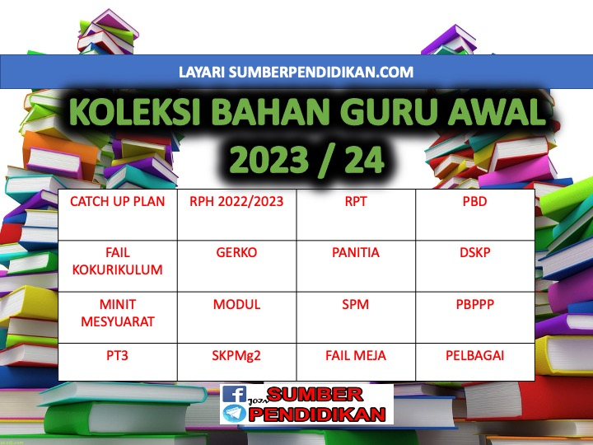

RPT
SCIENCE YEAR 2
2023/2024

WEEK | CONTENT STANDARD | LEARNING STANDARD | NOTE
WEEK 1  KUMPULAN A  19 March – 23 March 2024  KUMPULAN B  20 March – 24 March 2024 | 1.1 Science Process Skills | - Observe  1.1.2 Classify
WEEK 2  KUMPULAN A  26 March – 30 March 2023  KUMPULAN B  27 March – 31 March 2023 |  | - Measure and use numbers  1.1.4 Communicate
WEEK 3

KUMPULAN A
2 April – 6 April 2023

KUMPULAN B
3 April – 7 April 2023
WEEK 4  KUMPULAN A  9 April – 13 April 2023  KUMPULAN B  10 April – 14 April 2023 | 1.2 Manipulative Skills | 1.2.1 Use and handle science apparatus and substances  correctly.  1.2.2 Handle specimens correctly and carefully.  1.2.3 Sketch specimens, apparatus and science  substances correctly.  1.2.4 Clean science apparatus correctly.  1.2.5 Store science apparatus and substances correctly and  safely.
WEEK 5  KUMPULAN A  16 April – 20 April  KUMPULAN B  17 April – 21 April | 2.1 Science room rules | 2.1.1 Adhere to science room rules
KUMPULAN A  23 April – 27 April 2023  KUMPULAN B  24 April – 28 April 2023 | Cuti Pertengahan Penggal 1
WEEK 6  KUMPULAN A  30 April – 4 May 2023  KUMPULAN B  1 May – 5 May 2023 | 3.1 Reproduction and growth in human | 3.1.1 State how humans reproduce.
WEEK 7  KUMPULAN A  7 May – 11 May 2023  KUMPULAN B  8 May – 12 May 2023 |  | 3.1.2 Describe changes in size, height and weight in an  Make generalization that growths among individuals are different by carrying out activities.  3.1.3 Describe changes in an individual since birth.  (i) size;  (ii) height; and  (iii) weight.  individual since birth.
WEEK 8  KUMPULAN A  14 May – 18 May 2023  KUMPULAN B  15 May – 19 May 2023 |  | 3.1.4 Describe that offsprings inherit features from their parents or ancestors.
WEEK 9  KUMPULAN A  21 May – 25 May 2023  KUMPULAN B  22 May – 26 May 2023 |  | 3.1.5 Give examples of features inherited by the offsprings from their parents or ancestors such  as skin colour, iris colour and hair type.  3.1.6 Explain observations about growth and heredity using  sketches, ICT, in written or verbal form.
KUMPULAN A  28 May – 1 June 2023  KUMPULAN B  29 May – 2 June 2023 | Cuti Penggal 1
WEEK 10  KUMPULAN A  4 June – 8 June 2023  KUMPULAN B  5 June – 9 June 2023 | 4.1 Reproduction and growth in animal | 4.1.1 State how animals reproduce.  4.1.2 Classify animals according to the way they reproduce.
WEEK 11  KUMPULAN A  11 June – 15 June 2023  KUMPULAN B  12 June – 16 June 2023 |  | 4.1.3 Explain with examples animals that lay many eggs and animals that lay less egg.  4.1.4 Explain with examples animals that give birth to many young and animals that give birth to less young.
WEEK 12  KUMPULAN A  18 – 22 June 2023  KUMPULAN B  19 – 23 June 2023 |  | 4.1.5 Record the changes in the animals’ growth by observing their life cycles.
WEEK 13  KUMPULAN A  25 June – 29 June 2023  KUMPULAN B  26 June – 30 June 2023 |  | 4.1.6 Explain with examples young animals that look like their  parents and animals which do not look like their parents.  4.1.7 Explain observations about reproduction and growth in  animals using sketches, ICT, in written or verbal form.
WEEK 14  KUMPULAN A  2 July – 6 July 2023  KUMPULAN B  3 July – 7 July 2023 | 5.1 Growth of Plants | 5.1.1 State the importance of plants to humans and animals.
WEEK 15  KUMPULAN A  9 July – 13 July 2023  KUMPULAN B  10 July – 14 July 2023 |  | 5.1.2 State the basic needs for the seeds to germinate.  5.1.3 Record changes in plant’s growth by observing the  actual seeds from germination stage.
WEEK 16  KUMPULAN A  16 July – 20 July 2023  KUMPULAN B  17 July – 21 July 2023 |  | 5.1.4 Arrange in sequence the stages in a plant’s growth.
WEEK 17  KUMPULAN A  23 July – 27 July 2023  KUMPULAN B  24 July – 28 July 2023 |  | 5.1.5 Conclude the basic needs for a plant’s growth by carrying out  Investigations  5.1.6 Explain observations about life process of plants using sketches, ICT, in written or  verbal form.
WEEK 18  KUMPULAN A  30 July – 3 August 2023  KUMPULAN B  31 July – 4 August 2023 | 6.1 Light and dark | 6.1.1 State sources of light.  6.1.2 Differentiate the activities  carried out in light and dark situation.
WEEK 19  KUMPULAN A  6 August – 10 August 2023  KUMPULAN B  7 August – 11 August 2023 |  | 6.1.3 Explain how shadow is formed by carrying out  activities.
WEEK 20  KUMPULAN A  13 August – 17 August 2023  KUMPULAN B  14 August – 18 August 2023 |  | 6.1.4 Compare and contrast the clarity of shadows when light  is blocked by different objects by carrying out investigations.
WEEK 21

KUMPULAN A
20 August – 24 August 2023

KUMPULAN B
21 August – 25 August 2023
KUMPULAN A  27 August – 31 August 2023  KUMPULAN B  28 August – 1 Sept 2023 | Cuti Penggal 2
WEEK 10  KUMPULAN A  4 June – 8 June 2023  KUMPULAN B  5 June – 9 June 2023 |  | 6.1.5 Create a shadow game  6.1.6 Explain observations about light and dark using sketches,  ICT, in written or verbal form.
WEEK 22  KUMPULAN A  3 Sept – 7 Sept 2023  KUMPULAN B  4 Sept – 8 Sept 2023 | 7.1 Electric circuit | 7.1.1 Identify components in an electric circuit i.e. dry cell,  bulb and switch.
WEEK 23  KUMPULAN A  10 Sept – 14 Sept 2023  KUMPULAN B  11 Sept – 15 Sept 2023 |  | 7.1.2 Explain functions of the components in a complete  electric circuit.  7.1.3 Build a complete electric circuit using dry cell, bulb,  switch and connecting wires.
WEEK 24  KUMPULAN A  17 Sept – 21 Sept 2023  KUMPULAN B  18 Sept – 22 Sept 2023 |  | 7.1.4 Predict why bulb does not light up in a circuit.  7.1.5 Record whether a bulb will light up when the switch is  replaced with other objects or materials by carrying out investigations.
WEEK 25  KUMPULAN A  24 Sept – 28 Sept 2023  KUMPULAN B  25 Sept – 29 Sept 2023 |  | 7.1.6 Make generalization of objects that can light up a  bulb in a circuit are conductors and objects that cannot light up a bulb are insulators.  7.1.7 Explain observations about electric circuit using sketches,  ICT, in written or verbal form.
WEEK 26  KUMPULAN A  1 Oktober – 5 Oktober 2023  KUMPULAN B  2 Oktober – 6 Oktober 2023 | 8.1 Mixture | 8.1.1 Describe methods to separate a mixture of various materials  or objects.
WEEK 27  KUMPULAN A  8 Oktober – 12 Oktober 2023  KUMPULAN B  9 Oktober – 13 Oktober 2023 |  | 8.1.2 Provide reasoning about the method used to separate a  mixture of various materials or objects.
WEEK 28  KUMPULAN A  15 Oktober – 19 Oktober 2023  KUMPULAN B  16 Oktober – 20 Oktober 2023 |  | 8.1.3 Identify materials that can dissolve and cannot dissolve in water by carrying out investigations.
WEEK 29  KUMPULAN A  22 Oktober – 26 Oktober 2023  KUMPULAN B  23 Oktober – 27 Oktober 2023 |  | 8.1.4 Summarize how materials can be dissolved more quickly by  carrying out investigations.  8.1.5 Explain observations about mixtures using sketches, ICT,  in written or verbal form.
WEEK 30  KUMPULAN A  29 Oktober – 2 November 2023  KUMPULAN B  30 Oktober – 3 November 2023 | 9.1 Water | 9.1.1 State natural sources of water such as rain, rivers,  lakes, seas and springs.  9.1.2 State direction of water flow by carrying out activities.
WEEK 31  KUMPULAN A  5 November – 9 November 2023  KUMPULAN B  6 November – 10 November 2023 |  | 9.1.3 Make generalisation on natural direction of water flow  such as in rivers and waterfalls through observation using various media.
WEEK 32  KUMPULAN A  12 November –16 November 2023  KUMPULAN B  13 November –17 November 2023 |  | 9.1.4 Arrange in sequence the natural water cycle.  9.1.5 Explain observations about water cycle using sketches,  ICT, in written or verbal form.
WEEK 33  KUMPULAN A  19 November – 23 November 2023  KUMPULAN B  20 November – 24 November 2023 | 9.2 Air | 9.2.1 State that air is around us.  9.2.2 State that air consists of  gases such as oxygen and carbon dioxide.
WEEK 34  KUMPULAN A  26 November – 30 November 2023  KUMPULAN B  27 November – 1 December 2023 |  | 9.2.3 Describe that moving air is wind.  9.2.4 Generate ideas on the effects of air movement in everyday  life.  9.2.5 Create a tool or model by applying knowledge that  demonstrates usage of air movement.
WEEK 35  KUMPULAN A  3 December – 7 December 2023  KUMPULAN B  4 December – 8 December 2023 | 10.1 Building set | 10.1.1 Choose a structure to build from the building set.  10.1.2 Identify the building components according to the  illustrated manual.
WEEK 36  KUMPULAN A  10 December – 14 December 2023  KUMPULAN B  11 December – 15 December 2023 |  | 10.1.3 Assemble the building components according to the  illustrated manual.  10.1.4 Create a new structure that is not in the illustrated manual.
KUMPULAN A  17 December – 21 December 2023  KUMPULAN B  18 December – 22 December 2023 | Cuti Penggal 3
KUMPULAN A  24 December – 28 December 2023  KUMPULAN B  25 December – 29 December 2023 | Cuti Penggal 3
WEEK 37  KUMPULAN A  31 December –4 January 2024  KUMPULAN B  1 January –5 January 2024 |  | 10.1.5 Disassemble the built structure in sequence and  store the components into a storage container.
WEEK 38

KUMPULAN A
7 January – 11 January 2024

KUMPULAN B
8 January – 12 January 2024
WEEK 39

KUMPULAN A
14 January – 18 January 2024

KUMPULAN B
15 January – 19 January 2024
WEEK 40

KUMPULAN A
21 January – 25 January 2024

KUMPULAN B
22 January – 26 January 2024

