PRAKATA
Alhamdulilllah, Terima kasih kepada rakan-rakan guru dan team sumberpendidikan kerana menyediakan RPT 2023/2024 untuk kegunaan guru-guru di Malaysia.
Muaturun Percuma…
**DILARANG UNTUK MENGAMBIL SEBARANG BENTUK DAN JENIS KEUNTUNGAN DARIPADA PIHAK KAMI DAN WEB INI SAMA ADA SECARA LANGSUNG ATAU TIDAK LANGSUNG.**
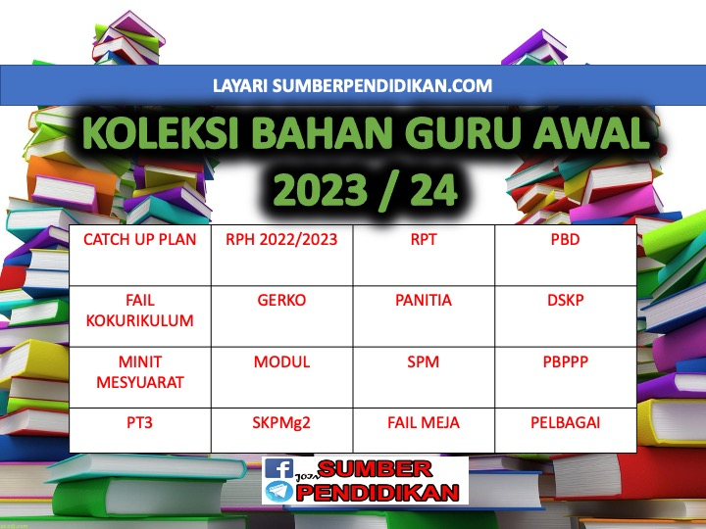

RPT SCIENCE YEAR 3 KSSR SEMAKAN 2023/2024
WEEK | CONTENT STANDARD | LEARNING STANDARD | NOTE
WEEK 1  KUMPULAN A  19 March – 23 March 2024  KUMPULAN B  20 March – 24 March 2024 | 1.1 Science Process Skills | 1.1.1Observe  1.1.2 Classify  1.1.3 Measure and use numbers
WEEK 2  KUMPULAN A  26 March – 30 March 2023  KUMPULAN B  27 March – 31 March 2023 |  | 1.1.4 Make inference  1.1.5 Predict  1.1.6 Communicate
WEEK 3  KUMPULAN A  2 April – 6 April 2023  KUMPULAN B  3 April – 7 April 2023 | 1.2 Manipulative Skills | 1.2.1 Use and handle apparatus and science substances  correctly.  1.2.2 Handle specimens correctly and carefully.  1.2.3 Sketch specimens, apparatus and science  substances correctly.  1.2.4 Clean science apparatus correctly.  1.2.5 Store science apparatus and substances correctly  and safely.
WEEK 4  KUMPULAN A  9 April – 13 April 2023  KUMPULAN B  10 April – 14 April 2023 | 2.1 Science room rules | 2.1.1  Adhere to science room rules
WEEK 5  KUMPULAN A  16 April – 20 April  KUMPULAN B  17 April – 21 April | 3.1 Teeth | 3.1.1 Describe the types of teeth and their functions.  3.1.2 Label the structure of the tooth.
KUMPULAN A  23 April – 27 April 2023  KUMPULAN B  24 April – 28 April 2023 | Cuti Pertengahan Penggal 1
WEEK 6  KUMPULAN A  30 April – 4 May 2023  KUMPULAN B  1 May – 5 May 2023 |  | 3.1.3 Compare and contrast sets of milk teeth and permanent  teeth.  3.1.4 Relate dental care with the structure of the tooth.  3.1.5 Explain the result of observations about teeth through written or verbal  forms, sketches or ICT in a creative way.
WEEK 7  KUMPULAN A  7 May – 11 May 2023  KUMPULAN B  8 May – 12 May 2023 | 3.2 Classes of food | 3.2.1 Give examples of food for each class of food.  3.2.2 Make generalisation about the importance of food  according to its class for the human body.
WEEK 8  KUMPULAN A  14 May – 18 May 2023  KUMPULAN B  15 May – 19 May 2023 |  | 3.2.3 Explain with examples of a balanced diet based on the  food pyramid.  3.2.4 Give reasons on the effects of imbalanced food intake.  3.2.5 Explain the result of observations about classes of food through written or verbal forms, sketches or ICT in a creative way.
WEEK 9  KUMPULAN A  21 May – 25 May 2023  KUMPULAN B  22 May – 26 May 2023 | 3.3 Digestion | 3.3.1 Describe the digestion process.  3.3.2 Arrange in sequence the flow of food during digestion.
KUMPULAN A  28 May – 1 June 2023  KUMPULAN B  29 May – 2 June 2023 | Cuti Penggal 1
WEEK 10  KUMPULAN A  4 June – 8 June 2023  KUMPULAN B  5 June – 9 June 2023 |  | 3.3.3 Conclude the digested food that is not required by the  body.  3.3.4 Explain the result of observations about digestion  through written or verbal forms, sketches or ICT in a creative way.
WEEK 11  KUMPULAN A  11 June – 15 June 2023  KUMPULAN B  12 June – 16 June 2023 | 4.1 Eating Habits | 4.1.1 Classify animals according to their eating habits
WEEK 12  KUMPULAN A  18 – 22 June 2023  KUMPULAN B  19 – 23 June 2023 |  | 4.1.2 Explain with examples the eating habits of herbivore,  carnivore and omnivore.
WEEK 13  KUMPULAN A  25 June – 29 June 2023  KUMPULAN B  26 June – 30 June 2023 |  | 4.1.3 Make inference about the animal groupings based on  their eating habits.
WEEK 14  KUMPULAN A  2 July – 6 July 2023  KUMPULAN B  3 July – 7 July 2023 |  | 4.1.4 Compare and constrast the dentition of herbivore,  carnivore and omnivore.
WEEK 15  KUMPULAN A  9 July – 13 July 2023  KUMPULAN B  10 July – 14 July 2023 |  | 4.1.5 Explain the result of observations about animals’  eating habits through written or verbal forms, sketches or ICT in a creative way.
WEEK 16  KUMPULAN A  16 July – 20 July 2023  KUMPULAN B  17 July – 21 July 2023 | 5.1 Plant Reproduction | 5.1.1 Give examples of plants for each way of reproduction.
WEEK 17  KUMPULAN A  23 July – 27 July 2023  KUMPULAN B  24 July – 28 July 2023 |  | 5.1.2 Give reasons on the importance of plant  reproduction to living things.
WEEK 18  KUMPULAN A  30 July – 3 August 2023  KUMPULAN B  31 July – 4 August 2023 |  | 5.1.3 Make generalisation that a plant can reproduce through various ways by carrying out  projects.  5.1.4 Explain the result of observations about plant  reproduction through written or verbal forms, sketches or ICT in a creative way.
WEEK 19  KUMPULAN A  6 August – 10 August 2023  KUMPULAN B  7 August – 11 August 2023 | 6.1 Measurement of area and  volume. | 6.1.1 State the units that are used to measure area and volume.
WEEK 20  KUMPULAN A  13 August – 17 August 2023  KUMPULAN B  14 August – 18 August 2023 |  | 6.1.2 Measure the area of regular surfaces using 1cm x 1cm  square.
WEEK 21

KUMPULAN A
20 August – 24 August 2023

KUMPULAN B
21 August – 25 August 2023
KUMPULAN A  27 August – 31 August 2023  KUMPULAN B  28 August – 1 Sept 2023 | Cuti Penggal 2
WEEK 22  KUMPULAN A  3 Sept – 7 Sept 2023  KUMPULAN B  4 Sept – 8 Sept 2023 |  | 6.1.3 Solve problems to estimate the area of irregular surfaces.
WEEK 23  KUMPULAN A  10 Sept – 14 Sept 2023  KUMPULAN B  11 Sept – 15 Sept 2023 |  | 6.1.4 Measure the volume of hollow boxes using 1cm x  1cm x 1cm cubes.
WEEK 24  KUMPULAN A  17 Sept – 21 Sept 2023  KUMPULAN B  18 Sept – 22 Sept 2023 |  | 6.1.5 Measure the volume of liquid using correct tools and  techniques.  6.1.6 Solve problems to determine the volume of irregular  shaped solids using water displacement method.  6.1.7 Explain the result of observations about the  measurement of area and volume through written or verbal forms, sketches or ICT in a creative way.
WEEK 25  KUMPULAN A  24 Sept – 28 Sept 2023  KUMPULAN B  25 Sept – 29 Sept 2023 | 7.1 Objects or materials  which are more or less dense than water. | 7.1.1 Make inferences about objects or materials that  float or sink by carrying out activities.
WEEK 26  KUMPULAN A  1 Oktober – 5 Oktober 2023  KUMPULAN B  2 Oktober – 6 Oktober 2023 |  | 7.1.2 Relate objects or materials that float and objects or  materials that sink with density.
WEEK 27  KUMPULAN A  8 Oktober – 12 Oktober 2023  KUMPULAN B  9 Oktober – 13 Oktober 2023 |  | 7.1.3 Solve problems to identify methods to make water  more dense.  7.1.4 Explain the result of observations about object  or materials which are more or less dense through written or verbal forms, sketches or ICT in a creative way.
WEEK 28  KUMPULAN A  15 Oktober – 19 Oktober 2023  KUMPULAN B  16 Oktober – 20 Oktober 2023 | 8.1 Acid and alkali | 8.1.1 Test acidic, alkaline and neutral substances through  changes in colour of litmus paper by carrying out investigation.
WEEK 29  KUMPULAN A  22 Oktober – 26 Oktober 2023  KUMPULAN B  23 Oktober – 27 Oktober 2023 |  | 8.1.2 Make generalisation on acidic, alkaline and neutral  substances through taste and touch by testing a few substances.
WEEK 30  KUMPULAN A  29 Oktober – 2 November 2023  KUMPULAN B  30 Oktober – 3 November 2023 |  | 8.1.3 Explore other materials to test acidic, alkaline and  neutral substances.  8.1.4 Explain the result of observations about acid and  alkali through written or verbal forms, sketches or ICT in a creative way.
WEEK 31  KUMPULAN A  5 November – 9 November 2023  KUMPULAN B  6 November – 10 November 2023 | 9.1 Solar System | 9.1.1 List member of the Solar System using various  media.
WEEK 32  KUMPULAN A  12 November –16 November 2023  KUMPULAN B  13 November –17 November 2023 |  | 9.1.2 Make generalisation of the planets’ temperature based  on their sequence in the Solar System.  9.1.3 Describe the planets that revolve around the Sun on  their orbits.
WEEK 33  KUMPULAN A  19 November – 23 November 2023  KUMPULAN B  20 November – 24 November 2023 |  | 9.1.4 Relate the positions of the planets from the Sun with  the time taken for the planets to revolve around the Sun.  9.1.5 Explain the result of observations about Solar  System through written or verbal forms, sketches or ICT in a creative way.
WEEK 34  KUMPULAN A  26 November – 30 November 2023  KUMPULAN B  27 November – 1 December 2023 | 10.1 Pulley | 10.1.1 State the meaning and the uses of pulleys.
KUMPULAN A  17 December – 21 December 2023  KUMPULAN B  18 December – 22 December 2023 | Cuti Penggal 3
KUMPULAN A  24 December – 28 December 2023  KUMPULAN B  25 December – 29 December 2023 | Cuti Penggal 3
WEEK 37  KUMPULAN A  31 December –4 January 2024  KUMPULAN B  1 January –5 January 2024 |  | 10.1.2 Describe how a fixed pulley works using a  model.
WEEK 38  KUMPULAN A  7 January – 11 January 2024  KUMPULAN B  8 January – 12 January 2024 |  | 10.1.3 Give examples of the application of pulleys in  life.
WEEK 39  KUMPULAN A  14 January – 18 January 2024  KUMPULAN B  15 January – 19 January 2024 |  | 10.1.4 Create a functional model of a pulley.  10.1.5 Explain the result of observations about pulley  through written or verbal forms, sketches or ICT in a creative way.
WEEK 40

KUMPULAN A
21 January – 25 January 2024

KUMPULAN B
22 January – 26 January 2024
WEEK 41

KUMPULAN A
28 January – 1 February 2024

KUMPULAN B
29 January – 2 February 2024
WEEK 42

KUMPULAN A
4 February – 8 February 2024

KUMPULAN B
5 February – 9 February 2024

