PRAKATA
Alhamdulilllah, Terima kasih kepada rakan-rakan guru dan team sumberpendidikan kerana menyediakan RPT 2025 untuk kegunaan guru-guru di Malaysia.
Muaturun Percuma…
**DILARANG UNTUK MENGAMBIL SEBARANG BENTUK DAN JENIS KEUNTUNGAN DARIPADA PIHAK KAMI DAN WEB INI SAMA ADA SECARA LANGSUNG ATAU TIDAK LANGSUNG.**
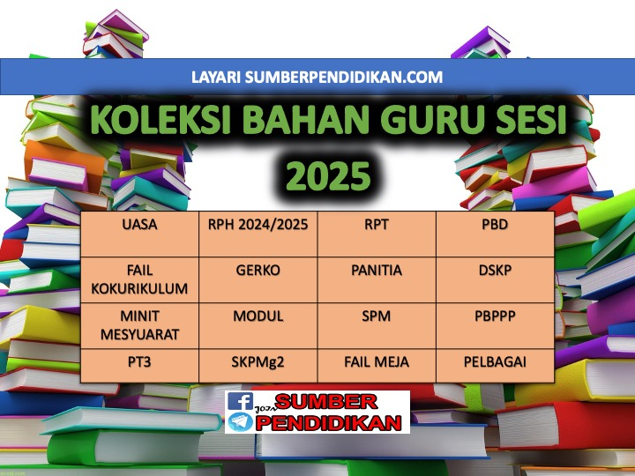

SCHEME OF WORK ENGLISH LANGUAGE FORM 3
YEAR 2025

WEEK | TYPES | LESSON | PAGE  (SOW) | THEME | UNIT  (CLOSE UP)
MINGGU 1  Kumpulan A  16 Februari – 22 Februari 2025  Kumpulan B  17 Februari – 23 Februari 2025 | TB | 1, 2, 3 | 27 - 29 | People and Culture | Family Ties
MINGGU 2  Kumpulan A  23 Februari – 1 Mac 2025  Kumpulan B  24 Februari – 2 Mac 2025 | TB | 4, 5, 6 | 30 - 32 | People and Culture | Family Ties
MINGGU 3  Kumpulan A  2 Mac – 8 Mac 2025  Kumpulan B  3 Mac – 9 Mac 2025 | TB | 7, 8, 9 | 33 - 35 | People and Culture | Family Ties
MINGGU 4  Kumpulan A  9 Mac – 15 Mac 2025  Kumpulan B  10 Mac – 16 Mac 2025  MINGGU 5  Kumpulan A  16 Mac – 22 Mac 2025  Kumpulan B  17 Mac – 23 Mac 2025 | NTB | 10 | 36 | N/A | Teacher to select
 | TB | 11, 12 | 37 – 38 | People and Culture | Food,Food, Food!
MINGGU 6  Kumpulan A  23 Mac - 29 Mac 2025  Kumpulan B  24 Mac - 30 Mac 2025 | TB | 13, 14, 15 | 39 - 41 | People and Culture | Food,Food, Food!
MINGGU 7  Kumpulan A  30 Mac - 5 April 2025  Kumpulan B  31 Mac - 6 April 2025 | TB | 16, 17 | 42 - 43 | People and Culture | Food,Food, Food!
MINGGU 8  Kumpulan A  6 April – 12 April 2025  Kumpulan B  7 April – 13 April 2025  MINGGU 9  Kumpulan A  13 April – 19 April 2025  Kumpulan B  14 April – 20 April 2025 | TB | 18, 19, 20 | 44 – 45 | People and Culture | Food,Food, Food!
 | NTB | 20 | 46 | N/A | Teacher to select
MINGGU 10  Kumpulan A  20 April – 26 April 2025  Kumpulan B  21 April – 27 April 2025 | TB | 21, 22, 23 | 47 – 49 | Health and Environment | The Wonders of Nature
MINGGU 11  Kumpulan A  27 April – 3 Mei 2025  Kumpulan B  28 April – 4 Mei 2025 | TB | 24, 25, 26 | 50 - 52 | Health and Environment | The Wonders of Nature
MINGGU 12  Kumpulan A  4 Mei – 10 Mei 2025  Kumpulan B  5 Mei – 11 Mei 2025 | TB | 27, 28, 29 | 53 - 55 | Health and Environment | The Wonders of Nature
MINGGU 13  Kumpulan A  11 Mei – 17 Mei 2025  Kumpulan B  12 Mei – 18 Mei 2025  MINGGU 14  Kumpulan A  18 Mei – 24 Mei 2025  Kumpulan B  19 Mei – 25 Mei 2025 | NTB | 30 | 56 | N/A | Teacher to select
 | TB | 31, 32 | 57 - 58 | Health and Environment | Special Relationships
MINGGU 15  Kumpulan A  25 Mei – 31 Mei 2025  Kumpulan B  26 Mei – 1 Jun 2025 | TB | 33, 34, 35 | 59 - 61 | Health and Environment | Special Relationships
MINGGU 16  Kumpulan A  8 Jun – 14 Jun 2025  Kumpulan B  9 Jun – 15 Jun 2025 | TB | 36, 37, 38 | 62 - 65 | Health and Environment | Special Relationships
MINGGU 17  Kumpulan A  15 Jun – 21 Jun 2025  Kumpulan B  16 Jun – 22 Jun 2025  MINGGU 18  Kumpulan A  22 Jun – 28 Jun 2025  Kumpulan B  23 Jun – 29 Jun 2025 | TB | 39 | 65 | Health and Environment | Special Relationships
 | NTB | 40 | 66 | N/A | Teacher to select
MINGGU 19  Kumpulan A  29 Jun – 5 Julai 2025  Kumpulan B  30 Jun – 6 Julai 2025 | TB | 41, 42, 43 | 67 - 69 | Science and Technology | A Place to Call Home
MINGGU 20  Kumpulan A  6 Julai - 12 Julai 2025  Kumpulan B  7 Julai - 13 Julai 2025 | TB | 44, 45, 46 | 70 - 72 | Science and Technology | A Place to Call Home
MINGGU 21  Kumpulan A  13 Julai – 19 Julai 2025  Kumpulan B  14 Julai – 20 Julai 2025 | TB | 47, 48, 49 | 73 - 75 | Science and Technology | A Place to Call Home
MINGGU 22
Kumpulan A
20 Julai – 26 Julai 2025

Kumpulan B
21 Julai – 27 Julai 2025
MINGGU 23  Kumpulan A  27 Julai – 2 Ogos 2025  Kumpulan B  MINGGU 23  28 Julai – 3 Ogos 2025  MINGGU 24  Kumpulan A  3 Ogos – 9 Ogos 2025  Kumpulan B  4 Ogos – 10 Ogos 2025 | NTB | 50 | 76 | N/A | Teacher to select
 | TB | 51, 52 | 76 - 78 | Health and Environment | Ready, Steady, Go!
MINGGU 25  Kumpulan A  10 Ogos – 16 Ogos 2025  Kumpulan B  11 Ogos – 17 Ogos 2025 | TB | 53, 54, 55 | 79 – 81 | Health and Environment | Ready, Steady, Go!
MINGGU 26  Kumpulan A  17 Ogos – 23 Ogos 2025  Kumpulan B  18 Ogos – 24 Ogos 2025  MINGGU 27  Kumpulan A  24 Ogos – 30 Ogos 2025  Kumpulan B  25 Ogos – 31 Ogos 2025 | TB | 56, 57  (REVISION) | 82 | N/A | Teacher to select
 | TB | 58 | 83 | Health and Environment | Ready, Steady, Go!
MINGGU 28  Kumpulan A  31 Ogos – 6 September 2025  Kumpulan B  1 September – 7 September 2025 | TB | 59, 60 | 84 – 85 | Health and Environment | Ready, Steady, Go!
 | NTB | 61 | 86 | N/A | Teacher to select
MINGGU 29  Kumpulan A  7 September – 13 September 2025  Kumpulan B  8 September – 14 September 2025 | TB | 62, 63, 64 | 87 – 89 | Health and Environment | Extreme Situations
MINGGU 30  Kumpulan A  21 September – 27 September 2025  Kumpulan B  22 September – 28 September 2025 | TB | 65, 66, 67 | 90 – 92 | Health and Environment | Extreme Situations
MINGGU 31  Kumpulan A  28 September – 4 Oktober 2025  Kumpulan B  29 September – 5 Oktober 2025 | TB | 68, 69, 70 | 93 - 95 | Health and Environment | Extreme Situations
MINGGU 32  Kumpulan A  5 Oktober - 11 Oktober 2025  Kumpulan B  6 Oktober - 12 Oktober 2025 | NTB | 71 | 96 | N/A | Teacher to select
 | TB | 72, 73 | 97 – 98 | People and Culture | Time to Spare
MINGGU 33  Kumpulan A  12 Oktober – 18 Oktober 2025  Kumpulan B  13 Oktober – 19 Oktober 2025 | TB | 74, 75 | 99–100 | People and Culture | Time to Spare
MINGGU 34  Kumpulan A  19 Oktober – 25 Oktober 2025  Kumpulan B  20 Oktober – 26 Oktober 2025 | TB | 76, 77, 78 | 101-103 | People and Culture | Time to Spare
MINGGU 35  Kumpulan A  26 Oktober – 1 November 2025  Kumpulan B  27 Oktober – 2 November 2025 | TB | 79, 80 | 104-105 | People and Culture | Time to Spare
 | NTB | 81 | 106 | N/A | Teacher to select
MINGGU 36  Kumpulan A  2 November – 8 November 2025  Kumpulan B  3 November – 9 November 2025 | TB | 82, 83, 84 | 107-109 | Science and Technology | High-Tech World
 | TB | 85, 86, 87 | 110-112 | Science and Technology | High-Tech World
MINGGU 37  Kumpulan A  9 November – 15 November 2025  Kumpulan B  10 November – 16November 2025 | TB | 88, 89, 90 | 113-115 | Science and Technology | High-Tech World
 | NTB | 91 | 116 | N/A | Teacher to select
 | TB | 92, 93 | 117-118 | People and Culture | That’s Entertainment
MINGGU 37  Kumpulan A  9 November – 15 November 2025  Kumpulan B  10 November – 16November 2025 | TB | 94, 95, 96 | 119-121 | People and Culture | That’s Entertainment
MINGGU 38  Kumpulan A  16 November – 22 November 2025  Kumpulan B  17 November – 23 November 2025 | TB | 97, 98, 99 | 122-124 | People and Culture | That’s Entertainment
MINGGU 39  Kumpulan A  23 November – 29 November 2025  Kumpulan B  24 November – 30 November 2025 | TB | 100 | 125 | People and Culture | That’s Entertainment
 | NTB | 101 | 126 | N/A | Teacher to select
 | TB | 102, 103, 104 | 127-129 | People and Culture | Lessons to Learn
MINGGU 40  Kumpulan A  30 November – 6 Disember 2025  Kumpulan B  31 November – 7 Disember 2025 | TB | 105 | 130 | People and Culture | Lessons to Learn
 | TB/NTB | 106  (REVISION) | 131 | N/A | Teacher to select
 | TB | 107 | 132 | People and Culture | Lessons to Learn
 | NTB | 108 | 133 | N/A | Teacher to select
MINGGU 41  Kumpulan A  7 Disember - 13 Disember 2025  Kumpulan B  8 Disember - 14 Disember 2025 | TB | 109, 110  (REVISION) | 134 - 135 | N/A | Teacher to select
 | NTB | 111 – 112  (PBL) | 136 | N/A | Teacher to select

*NTB = NON TEXTBOOK BASED LESSON, TB = TEXTBOOK BASED LESSON

