PRAKATA
Alhamdulilllah, Terima kasih kepada rakan-rakan guru dan team sumberpendidikan kerana menyediakan RPT SESI 2025 untuk kegunaan guru-guru di Malaysia.
Muaturun Percuma…
**DILARANG UNTUK MENGAMBIL SEBARANG BENTUK DAN JENIS KEUNTUNGAN DARIPADA PIHAK KAMI DAN WEB INI SAMA ADA SECARA LANGSUNG ATAU TIDAK LANGSUNG.**
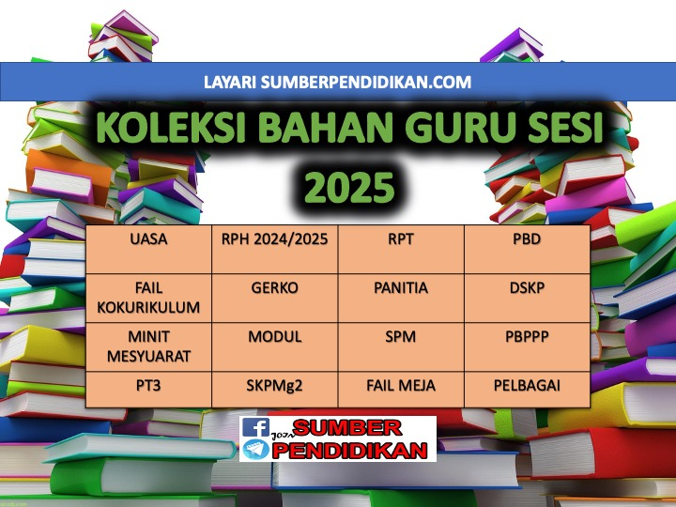

WEEK | CONTENT STANDARD | LEARNING STANDARD | NOTE
WEEK 1  Kumpulan A  16 Februari – 22 Februari 2025  Kumpulan B  17 Februari – 23 Februari 2025 |  | TRANSITION WEEK
WEEK 2  Kumpulan A  23 Februari – 1 Mac 2025  Kumpulan B  24 Februari – 2 Mac 2025 |  | TRANSITION WEEK
WEEK 3  Kumpulan A  2 Mac – 8 Mac 2025  Kumpulan B  3 Mac – 9 Mac 2025 |  | TRANSITION WEEK
WEEK 4  Kumpulan A  9 Mac – 15 Mac 2025  Kumpulan B  10 Mac – 16 Mac 2025 | 1.1 Science Process Skills | Pupils are able to:  - Observe  1.1.2 Communicate
WEEK 5  Kumpulan A  16 Mac – 22 Mac 2025  Kumpulan B  17 Mac – 23 Mac 2025 | 1.2 Manipulative Skills | 1.2.1 Use and handle science apparatus and substances correctly.  1.2.2 Handle specimens correctly and carefully.  1.2.3 Sketch specimens, apparatus and science substances correctly.  1.2.4 Clean science apparatus correctly.  1.2.5 Store science apparatus and substances correctly and safely.
WEEK 6  Kumpulan A  23 Mac - 29 Mac 2025  Kumpulan B  WEEK 6  24 Mac - 30 Mac 2025 | 2.1 Science room rules | 2.1.1 Adhere to science room rules
WEEK 7  Kumpulan A  30 Mac - 5 April 2025  Kumpulan B  31 Mac - 6 April 2025 | 3.1 Living things and non-living things | 3.1.1  Compare and contrast living things and non-living things based on the following characteristics:  (i) breathe;  (ii) need food and water;  (iii) move;  (iv) grow; and  (v) reproduce.
WEEK 8  Kumpulan A  6 April – 12 April 2025  Kumpulan B  7 April – 13 April 2025 |  | 3.1.2 Arrange in sequence the examples of living things based on their sizes
WEEK 9  Kumpulan A  13 April – 19 April 2025  Kumpulan B  14 April – 20 April 2025 | 3.2 Basic needs of living things | 3.2.1 State the basic needs of living things i.e. food, water and air.  3.2.2 Describe human, animals and plants need food, water and air in different ways.
WEEK 10  Kumpulan A  20 April – 26 April 2025  Kumpulan B  21 April – 27 April 2025 |  | 3.2.3 Describe human and animals also need shelters.  3.2.4 Provide reasoning on the importance of food, water, air and shelter to human and animals.  3.2.5 Explain observations on characteristics and basic needs of living things using sketches, ICT, writing or verbally.
WEEK 11  Kumpulan A  27 April – 3 Mei 2025  Kumpulan B  28 April – 4 Mei 2025 | 4.1 Human senses | 4.1.1 Identify parts of human body which related to senses.  4.1.2 Classify the objects according to identified characteristic.
WEEK 12  Kumpulan A  4 Mei – 10 Mei 2025  Kumpulan B  5 Mei – 11 Mei 2025 |  | 4.1.3 Use senses to identify objects through investigation.  4.1.4 Explain with examples, use other senses if one of the  senses is not functioning.  4.1.5 Explain observations about human senses using sketches, ICT, writing or  verbally.
WEEK 13  Kumpulan A  11 Mei – 17 Mei 2025  Kumpulan B  12 Mei – 18 Mei 2025 | 5.1 Parts of animals | 5.1.1 Identify the parts of animals e.g. beak, scales, fins, fine hair, feathers, horn, feelers, hard skin, shell, wings, head,  body, tail and webbed feet.
WEEK 14  Kumpulan A  18 Mei – 24 Mei 2025  Kumpulan B  19 Mei – 25 Mei 2025 |  | 5.1.2 Relate the parts of animals with their importance.  5.1.3 Explain through examples the parts of animals.
WEEK 15  Kumpulan A  25 Mei – 31 Mei 2025  Kumpulan B  26 Mei – 1 Jun 2025 |  | 5.1.4 Make generalisation that different animals may have  same parts of the body.
WEEK 16  Kumpulan A  8 Jun – 14 Jun 2025  Kumpulan B  9 Jun – 15 Jun 2025 |  | 5.1.5 Explain observations about parts of animals using sketches, ICT, writing or  verbally.
WEEK 17  Kumpulan A  15 Jun – 21 Jun 2025  Kumpulan B  16 Jun – 22 Jun 2025 | 6.1 Parts of plants | 6.1.1 Compare and contrast parts of plant i.e.:  (i) leaf: types of vein;  (ii) flower: flowering, non-  flowering;  (iii) stem: woody, non-  woody; and  (iv) root: tap root, fibre root.
WEEK 18  Kumpulan A  22 Jun – 28 Jun 2025  Kumpulan B  23 Jun – 29 Jun 2025 |  | 6.1.2 Relate the parts of plants i.e. leaf, flower, stem and root with  its importance to the plant.
WEEK 19  Kumpulan A  29 Jun – 5 Julai 2025  Kumpulan B  30 Jun – 6 Julai 2025 |  | 6.1.3 Make generalisation that different plants may have same  parts.
WEEK 20  Kumpulan A  6 Julai - 12 Julai 2025  Kumpulan B  7 Julai - 13 Julai 2025 |  | 6.1.4 Explain observations about parts of plants using sketches,  ICT, writing or verbally.
WEEK 21  Kumpulan A  13 Julai – 19 Julai 2025  Kumpulan B  14 Julai – 20 Julai 2025 | 7.1 Magnet | 7.1.1 Give examples the usage of magnets in daily life.  7.1.2 Identify the shapes of magnets e.g. bar, cylinder, horseshoe, U-shaped, button  and ring.
WEEK 22  Kumpulan A  20 Julai – 26 Julai 2025  Kumpulan B  21 Julai – 27 Julai 2025 |  | 7.1.3 Make generalisation on reactions of magnets to various objects by carrying  out activities.
WEEK 23  Kumpulan A  27 Julai – 2 Ogos 2025  Kumpulan B  28 Julai – 3 Ogos 2025 |  | 7.1.4 Conclude that magnet attracts or repels between two poles investigation.  through
WEEK 24  Kumpulan A  3 Ogos – 9 Ogos 2025  Kumpulan B  4 Ogos – 10 Ogos 2025 |  | 7.1.5 Determine the strengths of magnet towards object  through investigation.  7.1.6 Explain observations about magnets using sketches, ICT,  writing or verbally.
WEEK 25  Kumpulan A  10 Ogos – 16 Ogos 2025  Kumpulan B  11 Ogos – 17 Ogos 2025 | 8.1 The ability of materials to  absorb water | 8.1.1 Identify the objects that absorb water and cannot absorb water through  investigation.
WEEK 26  Kumpulan A  17 Ogos – 23 Ogos 2025  Kumpulan B  18 Ogos – 24 Ogos 2025 |  | 8.1.2 Classify objects that absorb water and cannot absorb  water.  8.1.3 Describe the ability of objects to absorb water based on types of materials through  investigation.
WEEK 27  Kumpulan A  24 Ogos – 30 Ogos 2025  Kumpulan B  25 Ogos – 31 Ogos 2025 |  | 8.1.4 State the importance of objects that absorb water and cannot absorb water in daily  life.
WEEK 28  Kumpulan A  31 Ogos – 6 September 2025  Kumpulan B  1 September – 7 September 2025 |  | 8.1.5 Design an object based on the ability to absorb water.  8.1.6 Explain observations about the ability of materials to  absorb water using sketches, ICT, writing or verbally.
WEEK 29  Kumpulan A  7 September – 13 September 2025  Kumpulan B  8 September – 14 September 2025 | 9.1 Surface of the Earth | 9.1.1  State the surface of the Earth e.g. mountain, beach, hill, valley, river, pond, lake and sea.
WEEK 30  Kumpulan A  21 September – 27 September 2025  Kumpulan B  22 September – 28 September 2025 | 9.2 Soil | 9.2.1 State the types of soils e.g. garden soil, clay and sand
WEEK 31  Kumpulan A  28 September – 4 Oktober 2025  Kumpulan B  29 September – 5 Oktober 2025 |  | 9.2.2 Compare and contrast the contents of different types of  soils through investigation.  9.2.3 Explain observation about the surface of the Earth and soil  using sketches, ICT, writing or verbally.
WEEK 32  Kumpulan A  5 Oktober - 11 Oktober 2025  Kumpulan B  6 Oktober - 12 Oktober 2025 | 10.1 Construction of basic shape  blocks | 10.1.1 Identify the basic shapes i.e. triangle, square, rectangle  and circle.
WEEK 33  Kumpulan A  12 Oktober – 18 Oktober 2025  Kumpulan B  13 Oktober – 19 Oktober 2025 |  | 10.1.2 Identify the basic shape blocks i.e. cube, cuboid, pyramid, prism, cone, cylinder  and sphere.
WEEK 34  Kumpulan A  19 Oktober – 25 Oktober 2025  Kumpulan B  20 Oktober – 26 Oktober 2025 |  | 10.1.3 Design an object or structure using basic shape blocks.
WEEK 35  Kumpulan A  26 Oktober – 1 November 2025  Kumpulan B  27 Oktober – 2 November 2025 |  | 10.1.4 Provide reasoning on the importance of different types  of blocks shape.
WEEK 36  Kumpulan A  2 November – 8 November 2025  Kumpulan B  3 November – 9 November 2025 |  | 10.1.5 Explain observations about the object built using sketches, ICT, writing or  verbally.
WEEK 37
Kumpulan A
9 November – 15 November 2025

Kumpulan B
10 November – 16November 2025
WEEK 38
Kumpulan A
16 November – 22 November 2025

Kumpulan B
17 November – 23 November 2025
WEEK 39
Kumpulan A
23 November – 29 November 2025

Kumpulan B
24 November – 30 November 2025

