PRAKATA
Alhamdulilllah, Terima kasih kepada rakan-rakan guru dan team sumberpendidikan kerana menyediakan RPT SESI 2025 untuk kegunaan guru-guru di Malaysia.
Muaturun Percuma…
**DILARANG UNTUK MENGAMBIL SEBARANG BENTUK DAN JENIS KEUNTUNGAN DARIPADA PIHAK KAMI DAN WEB INI SAMA ADA SECARA LANGSUNG ATAU TIDAK LANGSUNG.**
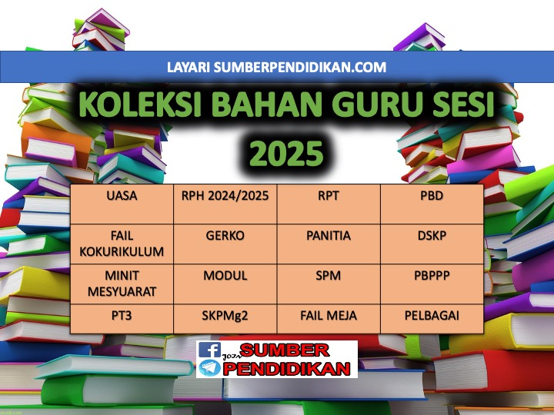

RPT
SCIENCE YEAR 2
2025

WEEK | CONTENT STANDARD | LEARNING STANDARD | NOTE
MINGGU 1  Kumpulan A  16 Februari – 22 Februari 2025  Kumpulan B  17 Februari – 23 Februari 2025 | 1.1 Science Process Skills | - Observe  1.1.2 Classify
MINGGU 2  Kumpulan A  23 Februari – 1 Mac 2025  Kumpulan B  24 Februari – 2 Mac 2025 |  | - Measure and use numbers  1.1.4 Communicate
MINGGU 3
Kumpulan A
2 Mac – 8 Mac 2025

Kumpulan B
3 Mac – 9 Mac 2025
MINGGU 4  Kumpulan A  9 Mac – 15 Mac 2025  Kumpulan B  10 Mac – 16 Mac 2025 | 1.2 Manipulative Skills | 1.2.1 Use and handle science apparatus and substances  correctly.  1.2.2 Handle specimens correctly and carefully.  1.2.3 Sketch specimens, apparatus and science  substances correctly.  1.2.4 Clean science apparatus correctly.  1.2.5 Store science apparatus and substances correctly and  safely.
MINGGU 5  Kumpulan A  16 Mac – 22 Mac 2025  Kumpulan B  17 Mac – 23 Mac 2025 | 2.1 Science room rules | 2.1.1 Adhere to science room rules
MINGGU 6  Kumpulan A  23 Mac - 29 Mac 2025  Kumpulan B  24 Mac - 30 Mac 2025 | 3.1 Reproduction and growth in human | 3.1.1 State how humans reproduce.
MINGGU 7  Kumpulan A  30 Mac - 5 April 2025  Kumpulan B  31 Mac - 6 April 2025 |  | 3.1.2 Describe changes in size, height and weight in an  Make generalization that growths among individuals are different by carrying out activities.  3.1.3 Describe changes in an individual since birth.  (i) size;  (ii) height; and  (iii) weight.  individual since birth.
MINGGU 8  Kumpulan A  6 April – 12 April 2025  Kumpulan B  7 April – 13 April 2025 |  | 3.1.4 Describe that offsprings inherit features from their parents or ancestors.
MINGGU 9  Kumpulan A  13 April – 19 April 2025  Kumpulan B  14 April – 20 April 2025 |  | 3.1.5 Give examples of features inherited by the offsprings from their parents or ancestors such  as skin colour, iris colour and hair type.  3.1.6 Explain observations about growth and heredity using  sketches, ICT, in written or verbal form.
MINGGU 10  Kumpulan A  20 April – 26 April 2025  Kumpulan B  21 April – 27 April 2025 | 4.1 Reproduction and growth in animal | 4.1.1 State how animals reproduce.  4.1.2 Classify animals according to the way they reproduce.
MINGGU 11  Kumpulan A  27 April – 3 Mei 2025  Kumpulan B  28 April – 4 Mei 2025 |  | 4.1.3 Explain with examples animals that lay many eggs and animals that lay less egg.  4.1.4 Explain with examples animals that give birth to many young and animals that give birth to less young.
MINGGU 12  Kumpulan A  4 Mei – 10 Mei 2025  Kumpulan B  5 Mei – 11 Mei 2025 |  | 4.1.5 Record the changes in the animals’ growth by observing their life cycles.
MINGGU 13  Kumpulan A  11 Mei – 17 Mei 2025  Kumpulan B  12 Mei – 18 Mei 2025 |  | 4.1.6 Explain with examples young animals that look like their  parents and animals which do not look like their parents.  4.1.7 Explain observations about reproduction and growth in  animals using sketches, ICT, in written or verbal form.
MINGGU 14  Kumpulan A  18 Mei – 24 Mei 2025  Kumpulan B  19 Mei – 25 Mei 2025 | 5.1 Growth of Plants | 5.1.1 State the importance of plants to humans and animals.
MINGGU 15  Kumpulan A  25 Mei – 31 Mei 2025  Kumpulan B  26 Mei – 1 Jun 2025 |  | 5.1.2 State the basic needs for the seeds to germinate.  5.1.3 Record changes in plant’s growth by observing the  actual seeds from germination stage.
MINGGU 16  Kumpulan A  8 Jun – 14 Jun 2025  Kumpulan B  9 Jun – 15 Jun 2025 |  | 5.1.4 Arrange in sequence the stages in a plant’s growth.
MINGGU 17  Kumpulan A  15 Jun – 21 Jun 2025  Kumpulan B  16 Jun – 22 Jun 2025 |  | 5.1.5 Conclude the basic needs for a plant’s growth by carrying out  Investigations  5.1.6 Explain observations about life process of plants using sketches, ICT, in written or  verbal form.
MINGGU 18  Kumpulan A  22 Jun – 28 Jun 2025  Kumpulan B  23 Jun – 29 Jun 2025 | 6.1 Light and dark | 6.1.1 State sources of light.  6.1.2 Differentiate the activities  carried out in light and dark situation.
MINGGU 19  Kumpulan A  29 Jun – 5 Julai 2025  Kumpulan B  30 Jun – 6 Julai 2025 |  | 6.1.3 Explain how shadow is formed by carrying out  activities.
MINGGU 20  Kumpulan A  6 Julai - 12 Julai 2025  Kumpulan B  7 Julai - 13 Julai 2025 |  | 6.1.4 Compare and contrast the clarity of shadows when light  is blocked by different objects by carrying out investigations.
MINGGU 21  Kumpulan A  13 Julai – 19 Julai 2025  Kumpulan B  14 Julai – 20 Julai 2025 |  | 6.1.5 Create a shadow game  6.1.6 Explain observations about light and dark using sketches,  ICT, in written or verbal form.
MINGGU 22
Kumpulan A
20 Julai – 26 Julai 2025

Kumpulan B
21 Julai – 27 Julai 2025
MINGGU 23  Kumpulan A  27 Julai – 2 Ogos 2025  Kumpulan B  28 Julai – 3 Ogos 2025 | 7.1 Electric circuit | 7.1.1 Identify components in an electric circuit i.e. dry cell,  bulb and switch.
MINGGU 24  Kumpulan A  3 Ogos – 9 Ogos 2025  Kumpulan B  4 Ogos – 10 Ogos 2025 |  | 7.1.2 Explain functions of the components in a complete  electric circuit.  7.1.3 Build a complete electric circuit using dry cell, bulb,  switch and connecting wires.
MINGGU 25  Kumpulan A  10 Ogos – 16 Ogos 2025  Kumpulan B  11 Ogos – 17 Ogos 2025 |  | 7.1.4 Predict why bulb does not light up in a circuit.  7.1.5 Record whether a bulb will light up when the switch is  replaced with other objects or materials by carrying out investigations.
MINGGU 26  Kumpulan A  17 Ogos – 23 Ogos 2025  Kumpulan B  18 Ogos – 24 Ogos 2025 |  | 7.1.6 Make generalization of objects that can light up a  bulb in a circuit are conductors and objects that cannot light up a bulb are insulators.  7.1.7 Explain observations about electric circuit using sketches,  ICT, in written or verbal form.
MINGGU 27  Kumpulan A  24 Ogos – 30 Ogos 2025  Kumpulan B  25 Ogos – 31 Ogos 2025 | 8.1 Mixture | 8.1.1 Describe methods to separate a mixture of various materials  or objects.
MINGGU 28  Kumpulan A  31 Ogos – 6 September 2025  Kumpulan B  1 September – 7 September 2025 |  | 8.1.2 Provide reasoning about the method used to separate a  mixture of various materials or objects.
MINGGU 29  Kumpulan A  7 September – 13 September 2025  Kumpulan B  8 September – 14 September 2025 |  | 8.1.3 Identify materials that can dissolve and cannot dissolve in water by carrying out investigations.
MINGGU 30  Kumpulan A  21 September – 27 September 2025  Kumpulan B  22 September – 28 September 2025 |  | 8.1.4 Summarize how materials can be dissolved more quickly by  carrying out investigations.  8.1.5 Explain observations about mixtures using sketches, ICT,  in written or verbal form.
MINGGU 31  Kumpulan A  28 September – 4 Oktober 2025  Kumpulan B  29 September – 5 Oktober 2025 | 9.1 Water | 9.1.1 State natural sources of water such as rain, rivers,  lakes, seas and springs.  9.1.2 State direction of water flow by carrying out activities.
MINGGU 32  Kumpulan A  5 Oktober - 11 Oktober 2025  Kumpulan B  6 Oktober - 12 Oktober 2025 |  | 9.1.3 Make generalisation on natural direction of water flow  such as in rivers and waterfalls through observation using various media.
MINGGU 33  Kumpulan A  12 Oktober – 18 Oktober 2025  Kumpulan B  13 Oktober – 19 Oktober 2025 |  | 9.1.4 Arrange in sequence the natural water cycle.  9.1.5 Explain observations about water cycle using sketches,  ICT, in written or verbal form.
MINGGU 34  Kumpulan A  19 Oktober – 25 Oktober 2025  Kumpulan B  20 Oktober – 26 Oktober 2025 | 9.2 Air | 9.2.1 State that air is around us.  9.2.2 State that air consists of  gases such as oxygen and carbon dioxide.
MINGGU 35  Kumpulan A  26 Oktober – 1 November 2025  Kumpulan B  27 Oktober – 2 November 2025 |  | 9.2.3 Describe that moving air is wind.  9.2.4 Generate ideas on the effects of air movement in everyday  life.  9.2.5 Create a tool or model by applying knowledge that  demonstrates usage of air movement.
MINGGU 36  Kumpulan A  2 November – 8 November 2025  Kumpulan B  3 November – 9 November 2025 | 10.1 Building set | 10.1.1 Choose a structure to build from the building set.  10.1.2 Identify the building components according to the  illustrated manual.
MINGGU 37  Kumpulan A  9 November – 15 November 2025  Kumpulan B  10 November – 16November 2025 |  | 10.1.3 Assemble the building components according to the  illustrated manual.  10.1.4 Create a new structure that is not in the illustrated manual.
MINGGU 38  Kumpulan A  16 November – 22 November 2025  Kumpulan B  17 November – 23 November 2025 |  | 10.1.5 Disassemble the built structure in sequence and  store the components into a storage container.
MINGGU 39
Kumpulan A
23 November – 29 November 2025

Kumpulan B
24 November – 30 November 2025
MINGGU 40
Kumpulan A
30 November – 6 Disember 2025

Kumpulan B
31 November – 7 Disember 2025
MINGGU 41
Kumpulan A
7 Disember - 13 Disember 2025

Kumpulan B
8 Disember - 14 Disember 2025
MINGGU 42
Kumpulan A
14 Disember – 20 Disember 2025

Kumpulan B
15 Disember – 21 Disember 2025

