PRAKATA
Alhamdulilllah, Terima kasih kepada rakan-rakan guru dan team sumberpendidikan kerana menyediakan RPT SESI 2025 untuk kegunaan guru-guru di Malaysia.
Muaturun Percuma…
**DILARANG UNTUK MENGAMBIL SEBARANG BENTUK DAN JENIS KEUNTUNGAN DARIPADA PIHAK KAMI DAN WEB INI SAMA ADA SECARA LANGSUNG ATAU TIDAK LANGSUNG.**
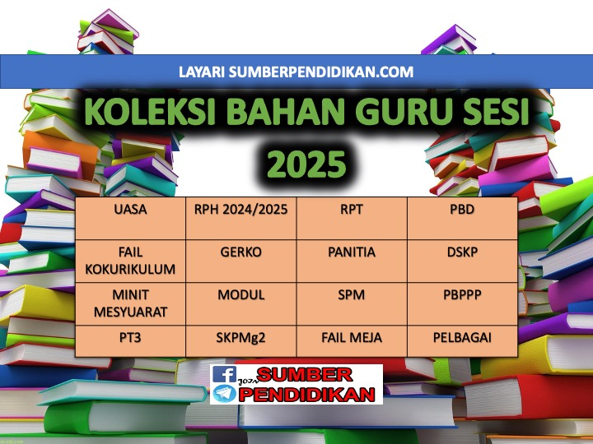

RPT SCIENCE YEAR 3 KSSR SEMAKAN 2025
WEEK | CONTENT STANDARD | LEARNING STANDARD | NOTE
WEEK 1  Kumpulan A  16 Februari – 22 Februari 2025  Kumpulan B  17 Februari – 23 Februari 2025 | 1.1 Science Process Skills | 1.1.1Observe  1.1.2 Classify  1.1.3 Measure and use numbers
WEEK 2  Kumpulan A  23 Februari – 1 Mac 2025  Kumpulan B  24 Februari – 2 Mac 2025 |  | 1.1.4 Make inference  1.1.5 Predict  1.1.6 Communicate
WEEK 3  Kumpulan A  2 Mac – 8 Mac 2025  Kumpulan B  3 Mac – 9 Mac 2025 | 1.2 Manipulative Skills | 1.2.1 Use and handle apparatus and science substances  correctly.  1.2.2 Handle specimens correctly and carefully.  1.2.3 Sketch specimens, apparatus and science  substances correctly.  1.2.4 Clean science apparatus correctly.  1.2.5 Store science apparatus and substances correctly  and safely.
WEEK 4  Kumpulan A  9 Mac – 15 Mac 2025  Kumpulan B  10 Mac – 16 Mac 2025 | 2.1 Science room rules | 2.1.1  Adhere to science room rules
WEEK 5  Kumpulan A  16 Mac – 22 Mac 2025  Kumpulan B  17 Mac – 23 Mac 2025 | 3.1 Teeth | 3.1.1 Describe the types of teeth and their functions.  3.1.2 Label the structure of the tooth.
WEEK 6  Kumpulan A  23 Mac - 29 Mac 2025  Kumpulan B  24 Mac - 30 Mac 2025 |  | 3.1.3 Compare and contrast sets of milk teeth and permanent  teeth.  3.1.4 Relate dental care with the structure of the tooth.  3.1.5 Explain the result of observations about teeth through written or verbal  forms, sketches or ICT in a creative way.
WEEK 7  Kumpulan A  30 Mac - 5 April 2025  Kumpulan B  31 Mac - 6 April 2025 | 3.2 Classes of food | 3.2.1 Give examples of food for each class of food.  3.2.2 Make generalisation about the importance of food  according to its class for the human body.
WEEK 8  Kumpulan A  6 April – 12 April 2025  Kumpulan B  7 April – 13 April 2025 |  | 3.2.3 Explain with examples of a balanced diet based on the  food pyramid.  3.2.4 Give reasons on the effects of imbalanced food intake.  3.2.5 Explain the result of observations about classes of food through written or verbal forms, sketches or ICT in a creative way.
WEEK 9  Kumpulan A  13 April – 19 April 2025  Kumpulan B  14 April – 20 April 2025 | 3.3 Digestion | 3.3.1 Describe the digestion process.  3.3.2 Arrange in sequence the flow of food during digestion.
WEEK 10  Kumpulan A  20 April – 26 April 2025  Kumpulan B  21 April – 27 April 2025 |  | 3.3.3 Conclude the digested food that is not required by the  body.  3.3.4 Explain the result of observations about digestion  through written or verbal forms, sketches or ICT in a creative way.
WEEK 11  Kumpulan A  27 April – 3 Mei 2025  Kumpulan B  28 April – 4 Mei 2025 | 4.1 Eating Habits | 4.1.1 Classify animals according to their eating habits
WEEK 12  Kumpulan A  4 Mei – 10 Mei 2025  Kumpulan B  5 Mei – 11 Mei 2025 |  | 4.1.2 Explain with examples the eating habits of herbivore,  carnivore and omnivore.
WEEK 13  Kumpulan A  11 Mei – 17 Mei 2025  Kumpulan B  12 Mei – 18 Mei 2025 |  | 4.1.3 Make inference about the animal groupings based on  their eating habits.
WEEK 14  Kumpulan A  18 Mei – 24 Mei 2025  Kumpulan B  19 Mei – 25 Mei 2025 |  | 4.1.4 Compare and constrast the dentition of herbivore,  carnivore and omnivore.
WEEK 15  Kumpulan A  25 Mei – 31 Mei 2025  Kumpulan B  26 Mei – 1 Jun 2025 |  | 4.1.5 Explain the result of observations about animals’  eating habits through written or verbal forms, sketches or ICT in a creative way.
WEEK 16  Kumpulan A  8 Jun – 14 Jun 2025  Kumpulan B  9 Jun – 15 Jun 2025 | 5.1 Plant Reproduction | 5.1.1 Give examples of plants for each way of reproduction.
WEEK 17  Kumpulan A  15 Jun – 21 Jun 2025  Kumpulan B  16 Jun – 22 Jun 2025 |  | 5.1.2 Give reasons on the importance of plant  reproduction to living things.
WEEK 18  Kumpulan A  22 Jun – 28 Jun 2025  Kumpulan B  23 Jun – 29 Jun 2025 |  | 5.1.3 Make generalisation that a plant can reproduce through various ways by carrying out  projects.  5.1.4 Explain the result of observations about plant  reproduction through written or verbal forms, sketches or ICT in a creative way.
WEEK 19  Kumpulan A  29 Jun – 5 Julai 2025  Kumpulan B  30 Jun – 6 Julai 2025 | 6.1 Measurement of area and  volume. | 6.1.1 State the units that are used to measure area and volume.
WEEK 20  Kumpulan A  6 Julai - 12 Julai 2025  Kumpulan B  7 Julai - 13 Julai 2025 |  | 6.1.2 Measure the area of regular surfaces using 1cm x 1cm  square.
WEEK 21  Kumpulan A  13 Julai – 19 Julai 2025  Kumpulan B  14 Julai – 20 Julai 2025 |  | 6.1.3 Solve problems to estimate the area of irregular surfaces.
WEEK 22
Kumpulan A
20 Julai – 26 Julai 2025

Kumpulan B
21 Julai – 27 Julai 2025
WEEK 23  Kumpulan A  27 Julai – 2 Ogos 2025  Kumpulan B  28 Julai – 3 Ogos 2025 |  | 6.1.4 Measure the volume of hollow boxes using 1cm x  1cm x 1cm cubes.
WEEK 24  Kumpulan A  3 Ogos – 9 Ogos 2025  Kumpulan B  4 Ogos – 10 Ogos 2025 |  | 6.1.5 Measure the volume of liquid using correct tools and  techniques.  6.1.6 Solve problems to determine the volume of irregular  shaped solids using water displacement method.  6.1.7 Explain the result of observations about the  measurement of area and volume through written or verbal forms, sketches or ICT in a creative way.
WEEK 25  Kumpulan A  10 Ogos – 16 Ogos 2025  Kumpulan B  11 Ogos – 17 Ogos 2025 | 7.1 Objects or materials  which are more or less dense than water. | 7.1.1 Make inferences about objects or materials that  float or sink by carrying out activities.
WEEK 26  Kumpulan A  17 Ogos – 23 Ogos 2025  Kumpulan B  18 Ogos – 24 Ogos 2025 |  | 7.1.2 Relate objects or materials that float and objects or  materials that sink with density.
WEEK 27  Kumpulan A  24 Ogos – 30 Ogos 2025  Kumpulan B  25 Ogos – 31 Ogos 2025 |  | 7.1.3 Solve problems to identify methods to make water  more dense.  7.1.4 Explain the result of observations about object  or materials which are more or less dense through written or verbal forms, sketches or ICT in a creative way.
WEEK 28  Kumpulan A  31 Ogos – 6 September 2025  Kumpulan B  1 September – 7 September 2025 | 8.1 Acid and alkali | 8.1.1 Test acidic, alkaline and neutral substances through  changes in colour of litmus paper by carrying out investigation.
WEEK 29  Kumpulan A  7 September – 13 September 2025  Kumpulan B  8 September – 14 September 2025 |  | 8.1.2 Make generalisation on acidic, alkaline and neutral  substances through taste and touch by testing a few substances.
WEEK 30  Kumpulan A  21 September – 27 September 2025  Kumpulan B  22 September – 28 September 2025 |  | 8.1.3 Explore other materials to test acidic, alkaline and  neutral substances.  8.1.4 Explain the result of observations about acid and  alkali through written or verbal forms, sketches or ICT in a creative way.
WEEK 31  Kumpulan A  28 September – 4 Oktober 2025  Kumpulan B  29 September – 5 Oktober 2025 | 9.1 Solar System | 9.1.1 List member of the Solar System using various  media.
WEEK 32  Kumpulan A  5 Oktober - 11 Oktober 2025  Kumpulan B  6 Oktober - 12 Oktober 2025 |  | 9.1.2 Make generalisation of the planets’ temperature based  on their sequence in the Solar System.  9.1.3 Describe the planets that revolve around the Sun on  their orbits.
WEEK 33  Kumpulan A  12 Oktober – 18 Oktober 2025  Kumpulan B  13 Oktober – 19 Oktober 2025 |  | 9.1.4 Relate the positions of the planets from the Sun with  the time taken for the planets to revolve around the Sun.  9.1.5 Explain the result of observations about Solar  System through written or verbal forms, sketches or ICT in a creative way.
WEEK 34  Kumpulan A  19 Oktober – 25 Oktober 2025  Kumpulan B  20 Oktober – 26 Oktober 2025 | 10.1 Pulley | 10.1.1 State the meaning and the uses of pulleys.
WEEK 35  Kumpulan A  26 Oktober – 1 November 2025  Kumpulan B  27 Oktober – 2 November 2025 |  | 10.1.2 Describe how a fixed pulley works using a  model.
WEEK 36  Kumpulan A  2 November – 8 November 2025  Kumpulan B  3 November – 9 November 2025 |  | 10.1.3 Give examples of the application of pulleys in  life.
WEEK 37  Kumpulan A  9 November – 15 November 2025  Kumpulan B  10 November – 16November 2025 |  | 10.1.4 Create a functional model of a pulley.  10.1.5 Explain the result of observations about pulley  through written or verbal forms, sketches or ICT in a creative way.
WEEK 38
Kumpulan A
16 November – 22 November 2025

Kumpulan B
17 November – 23 November 2025
WEEK 39
Kumpulan A
23 November – 29 November 2025

Kumpulan B
24 November – 30 November 2025
WEEK 40
Kumpulan A
30 November – 6 Disember 2025

Kumpulan B
31 November – 7 Disember 2025
WEEK 41
Kumpulan A
7 Disember - 13 Disember 2025

Kumpulan B
8 Disember - 14 Disember 2025
WEEK 42
Kumpulan A
14 Disember – 20 Disember 2025

Kumpulan B
15 Disember – 21 Disember 2025

