PRAKATA
Alhamdulilllah, Terima kasih kepada rakan-rakan guru dan team sumberpendidikan kerana menyediakan RPT SESI 2025 untuk kegunaan guru-guru di Malaysia.
Muaturun Percuma…
**DILARANG UNTUK MENGAMBIL SEBARANG BENTUK DAN JENIS KEUNTUNGAN DARIPADA PIHAK KAMI DAN WEB INI SAMA ADA SECARA LANGSUNG ATAU TIDAK LANGSUNG.**
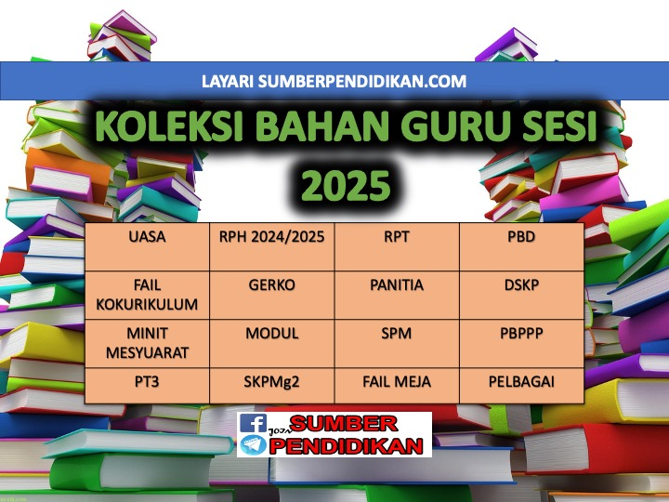

YEARLY LESSON PLAN
MATHEMATICS YEAR 2 KSSR SEMAKAN
2025

WEEK | CONTENT STANDARD | LEARNING STANDARD | NOTE
WEEK 1  Kumpulan A  16 Februari – 22 Februari 2025  Kumpulan B  17 Februari – 23 Februari 2025 | 1.1 Number value. | 1.1.1 Name the value of numbers up to 1000:  (i) Read any given number in words.  (ii) Say any given number in words.  (iii) Match the numerals with the words.  1.1.2 Determine the value of numbers up to 1000:  (i) Show the quantity of numbers given.  (ii) Match groups of objects with numbers.  (iii) Compare the value of two numbers.  (iv) Arrangegroupsofobjectsin  ascending and descending order.
WEEK 2  Kumpulan A  23 Februari – 1 Mac 2025  Kumpulan B  24 Februari – 2 Mac 2025 | 1.2 Write numbers. | 1.2.1 Write numbers in numerals and words.
WEEK 3  Kumpulan A  2 Mac – 8 Mac 2025  Kumpulan B  3 Mac – 9 Mac 2025 | 1.3 Number sequence | 1.3.1 Count numbers.  1.3.2 Complete any number sequence.
WEEK 4  Kumpulan A  9 Mac – 15 Mac 2025  Kumpulan B  10 Mac – 16 Mac 2025 | 1.4 Place value. | 1.4.1 State the place value and digit value of any number.  1.4.2 Partition any number according to place value and digit value.
WEEK 5  Kumpulan A  16 Mac – 22 Mac 2025  Kumpulan B  17 Mac – 23 Mac 2025 | 1.5 Estimate. | 1.5.1 Give reasonable estimation for the quantity of  objects.
WEEK 6  Kumpulan A  23 Mac - 29 Mac 2025  Kumpulan B  24 Mac - 30 Mac 2025 | 1.6 Round off numbers. | 1.6.1 Round off whole numbers to the nearest hundreds.
WEEK 7  Kumpulan A  30 Mac - 5 April 2025  Kumpulan B  31 Mac - 6 April 2025 | 1.7 Number patterns. | 1.7.1 Identify patterns for a given number series.  1.7.2 Complete various simple number patterns.
WEEK 8  Kumpulan A  6 April – 12 April 2025  Kumpulan B  7 April – 13 April 2025 | 1.8 Problem solving | 1.8.1 Solve problems involving daily life situations.
WEEK 9  Kumpulan A  13 April – 19 April 2025  Kumpulan B  14 April – 20 April 2025 | 2.1 Add within 1000. | 2.1.1 Add two numbers within the sum of 1000.  2.1.2 Add three numbers within the sum of 1000.
WEEK 10  Kumpulan A  20 April – 26 April 2025  Kumpulan B  21 April – 27 April 2025 | 2.2 Subtract within1000. | 2.2.1 Subtract two numbers within 1000.  2.2.2 Subtract two numbers from any one number  within 1000.
WEEK 11  Kumpulan A  27 April – 3 Mei 2025  Kumpulan B  28 April – 4 Mei 2025 | 2.3 Multiplywithin1000. | 2.3.1 Multiply in the range of basic facts.  2.3.2 Multiply one digit number with 10.
WEEK 12  Kumpulan A  4 Mei – 10 Mei 2025  Kumpulan B  5 Mei – 11 Mei 2025 | 2.4 Divide within 1000. | 2.4.1 Divide in the range of basic facts.  2.4.2 Divide any two digit number with 10.
WEEK 13  Kumpulan A  11 Mei – 17 Mei 2025  Kumpulan B  12 Mei – 18 Mei 2025 | 2.5 Problemsolving. | 2.5.1 Create stories involving addition, subtraction, multiplication and division within 1000.  2.5.2 Solve problems involving addition, subtraction,  multiplication and division in daily life situations.
WEEK 14  Kumpulan A  18 Mei – 24 Mei 2025  Kumpulan B  19 Mei – 25 Mei 2025 | 3.1 Properfractions. | 3.1.1 Identify and state the proper fractions with 1 as the  numerator and denominator up to 10.  3.1.2 Name the proper fractions with numerator up to 9 and denominator up to 10.  3.1.3 Represent with diagrams based on given fractions.  3.1.4 Writegivenproperfractions.  3.1.5 Compare the value of two proper fractions.
WEEK 15  Kumpulan A  25 Mei – 31 Mei 2025  Kumpulan B  26 Mei – 1 Jun 2025 | 3.2 Decimals. | 3.2.1 Convert fractions of tenths to decimals.  3.2.2 Say decimal numbers of zero point one up to zero  point nine.  3.2.3 Show decimal numbers of 0.1 to 0.9.  3.2.4 Representdiagramsbasedongivendecimal  numbers.  3.2.5 Writedecimalsasgiven.  3.2.6 Comparethevalueoftwogivendecimals.
WEEK 16  Kumpulan A  8 Jun – 14 Jun 2025  Kumpulan B  9 Jun – 15 Jun 2025 | 3.3 Fractions and decimals. | 3.3.1 Comparethegivenvaluesoffractionsand  decimals.
WEEK 17  Kumpulan A  15 Jun – 21 Jun 2025  Kumpulan B  16 Jun – 22 Jun 2025 | 4.1 Notesandcoins.  4.2 Addvaluesofmoney | 4. 1.1 Identify notes of Malaysian currency up to  RM100.  4.1.2 Determine the value of money up to RM100.  4.2.1 Add two values of money within the sum of RM100.  4.2.2 Add three values of money within the sum of RM100.
WEEK 18  Kumpulan A  22 Jun – 28 Jun 2025  Kumpulan B  23 Jun – 29 Jun 2025 | . 4.3 Subtractvaluesof money  4.4 Multiplyvaluesof money. | 4.3.1 Subtract two values of money within RM100.  4.3.2 Subtract two values of money consecutively  from any value within RM100.  4.4.1 Multiply values of money within the product of RM100.
WEEK 19  Kumpulan A  29 Jun – 5 Julai 2025  Kumpulan B  30 Jun – 6 Julai 2025 | 4.5 Dividevaluesofmoney  4.6 Savings and investment. | 4.5.1 Divide values of money within RM100  4.6.1 Manage finances effectively as basic of savings  and spending.
WEEK 20  Kumpulan A  6 Julai - 12 Julai 2025  Kumpulan B  7 Julai - 13 Julai 2025 | 5.1 Time in hours and minutes.. | 5.1.1 Recognise minute graduations on the clock  face.  5.1.2 State and show time in hours and minutes.
WEEK 21  Kumpulan A  13 Julai – 19 Julai 2025  Kumpulan B  14 Julai – 20 Julai 2025 |  | 5.1.3 Convert time in hours and minutes from words to numerals and vice versa.  5.1.4 Record time in hours and minutes..
WEEK 22
Kumpulan A
20 Julai – 26 Julai 2025

Kumpulan B
21 Julai – 27 Julai 2025
WEEK 23  Kumpulan A  27 Julai – 2 Ogos 2025  Kumpulan B  28 Julai – 3 Ogos 2025 | 5.2 Relationship in time. | 5.2.1 State the relationship between days with hours and hours with minutes.  5.3.1 Solve problems involving daily life situations.
WEEK 24  Kumpulan A  3 Ogos – 9 Ogos 2025  Kumpulan B  4 Ogos – 10 Ogos 2025 | 6.1 Length. | 6.1.1 Recognise unit of length .  6.1.2 Measure length.  6.1.3 Estimate length.
WEEK 25  Kumpulan A  10 Ogos – 16 Ogos 2025  Kumpulan B  11 Ogos – 17 Ogos 2025 | 6.2 Mass | 6.2.1 Recognise unit of mass.  6.2.2 Weigh objects.  6.2.3 Estimate mass.
WEEK 26  Kumpulan A  17 Ogos – 23 Ogos 2025  Kumpulan B  18 Ogos – 24 Ogos 2025 | 6.3 Volumeofliquid. | 6.3.1 Recognise volume of liquid.  6.3.2 Measure volume of liquid.  6.3.3 Estimate volume of liquid.
WEEK 27  Kumpulan A  24 Ogos – 30 Ogos 2025  Kumpulan B  25 Ogos – 31 Ogos 2025 | 6.4 Problem solving. | 6.4.1 Solve problems involving daily life situations.
WEEK 28  Kumpulan A  31 Ogos – 6 September 2025  Kumpulan B  1 September – 7 September 2025 | 7.1 Three-dimensional shapes. | 7.1.1 Identify three-dimensional shapes based on  descriptions.  7.1.2 Identify basic shapes of three-dimensional shapes.
WEEK 29  Kumpulan A  7 September – 13 September 2025  Kumpulan B  8 September – 14 September 2025 |  | 7.1.3 Identify various nets of three-dimensional shapes.
WEEK 30  Kumpulan A  21 September – 27 September 2025  Kumpulan B  22 September – 28 September 2025 | 7.2 Two-dimensional shapes. | 7.2.1 Identify two-dimensional shapes based on descriptions.
WEEK 31  Kumpulan A  28 September – 4 Oktober 2025  Kumpulan B  29 September – 5 Oktober 2025 |  | 7.2.2 Draw basic shapes of two-dimensional shapes.
WEEK 32  Kumpulan A  5 Oktober - 11 Oktober 2025  Kumpulan B  6 Oktober - 12 Oktober 2025 | 7.3 Problemsolving. | 7.3.1 Solve problems involving daily life situations.
WEEK 33  Kumpulan A  12 Oktober – 18 Oktober 2025  Kumpulan B  13 Oktober – 19 Oktober 2025 | 8.1 Collect, classify and arrange data. | 8.1.1 Collect data based on daily life situation.
WEEK 34  Kumpulan A  19 Oktober – 25 Oktober 2025  Kumpulan B  20 Oktober – 26 Oktober 2025 | 8.2 Barchart. | 8.1.2. Read and obtain information from bar chart.
WEEK 35  Kumpulan A  26 Oktober – 1 November 2025  Kumpulan B  27 Oktober – 2 November 2025 | 8.3 Problemsolving. | 8.3.1 Solve problems involving daily life situations.
WEEK 36
Kumpulan A
2 November – 8 November 2025

Kumpulan B
3 November – 9 November 2025
WEEK 37
Kumpulan A
9 November – 15 November 2025

Kumpulan B
10 November – 16November 2025
WEEK 38
Kumpulan A
16 November – 22 November 2025

Kumpulan B
17 November – 23 November 2025
WEEK 39
Kumpulan A
23 November – 29 November 2025

Kumpulan B
24 November – 30 November 2025
WEEK 40
Kumpulan A
30 November – 6 Disember 2025

Kumpulan B
31 November – 7 Disember 2025
WEEK 41
Kumpulan A
7 Disember - 13 Disember 2025

Kumpulan B
8 Disember - 14 Disember 2025
WEEK 42
Kumpulan A
14 Disember – 20 Disember 2025

Kumpulan B
15 Disember – 21 Disember 2025

